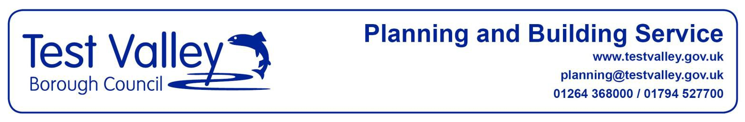

PLANNING AND BUILDING SERVICE

PRE-APPLICATION PLANNING ADVICE ENQUIRY - FEES SCHEDULE

(CHARGES FROM 1 AUGUST 2018)
Proposal | Fee  (inc.20% VAT)
Householder proposals | £58
Erection of Residential Development (The stated fees apply to both full and outline proposals)
i) 1 dwelling | £144
ii) 2-5 dwellings | £259
iii) 6-9 dwellings | £432
iv) 10-20 dwellings | £763
v) 21+ dwellings | 10% of full planning application fee plus VAT
Industrial/commercial/agricultural and all development not covered in other fee categories
i) 0 -99m2 | £108
ii) 100-499m2 | £288
iii) 500-999m2 | £540
iv) 1,000m2+  Areas relate to proposed floorspace(measured externally) or the area of development/works. Car parks, hardstandings, service roads or other accesses (only where required for a purpose incidental to the existing use of land) charged at i) rate. | £648 or 10% of full planning application fee plus VAT whichever greater
Other Development/Proposals
Change of use (including to residential) | £144
Advertisements | £58
Variation of condition | £60

See Over

PLANNING AND BUILDING SERVICE

PRE-APPLICATION PLANNING ADVICE ENQUIRY - FEES SCHEDULE

(CHARGES FROM 1 AUGUST 2018)
Reduced Fees
• Proposals by Parish Councils  • Proposals by non-profit making clubs or other non profit making sporting or recreational organisations, relating to playing fields for their own use.  • Follow up amended pre-application Major enquiries (where submitted within 3 months of date of response on initial pre application enquiry) | 50% reduction
Exemptions
• Affordable Housing Exception Schemes in Rural Areas by  Registered Providers  • Listed Building works not requiring planning permission  • Conservation Area demolition  • Article 4 directions  • Alterations to dwellinghouses or buildings to which members of the public are admitted, for the purpose of providing means of access for disabled people (or securing the safety, health or comfort of disabled people, in the case of dwellinghouses).  • Non-material amendments  • Extension of time for implementation  • Follow up amended pre-application Minor / Householder enquiries (where submitted within 3 months of date of response on initial pre application enquiry) | Free
Notes
• Where proposals include development falling in both the
‘residential’ category and ‘Industrial/commercial/agricultural and all development not covered in other fee categories’ category then the fees for both categories are added together.
• Where the proposal is for change of use and building works the higher of the two fees will apply.

Page 2

