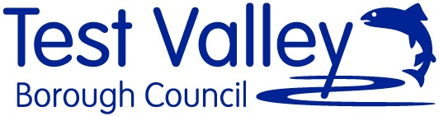  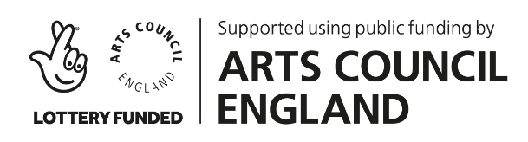 | With Hampshire Arts Network:  Basingstoke and Deane Borough Council  Eastleigh Borough Council  Havant Borough Council  Hampshire County Council  New Forest District Council  Rushmoor Borough Council  Test Valley Borough Council  Winchester City Council  & Thatcham Town Council

Project: Hampshire Outdoor Street Arts Commission
Free: £6,000
Deadline: Wednesday 26 January 2022

Vision
Test Valley Borough Council in Partnership with The Hampshire Arts Network (see members above) wish to commission an outdoor arts company or performance artists to create a unique, high quality and fun piece of performance or installation work to tour selected Hampshire towns and high streets in 2022.
The opportunity would suit emerging street and performance artists based or working in Hampshire but does not disqualify other established artists in the area wishing to apply.
We are open to applications from dance, theatre, music and visual artists. This is an exciting opportunity to introduce your work to communities across the county as well as to the programmers and arts officers who form the Hampshire Arts Network.
Aims
- To create a bespoke and inspiring new street performance piece to delight and entertain people in Hampshire.
- To create a performance that can adapt to a variety of audiences and outdoor environments
- To explore the themes of fun and wellbeing
- To allow a space for artists to create work for the places in which we live
Location
The projects is to create a new piece of work that can tour Hampshire and be programmed at various events across the county and with the partners of the Hampshire Arts Network. These include for example; Four Fun Fridays, Basingstoke Festival, Rushmoor Arts Festival, Eastleigh Summer Social, Thatcham’s summer programme, and others TBC.
Timeline
We will make the commission in February 2022 allowing the successful company up to 4 months to develop their work ready for the summer programmes of 2022.
Fee
£6,000
How to Apply
Your submission should include:
- A proposal of your initial ideas or approaches to the brief and your links to the Test Valley and Hampshire area. (Please note priority will be given to Hampshire based companies and artists)
- A budget breakdown
- Timeline of development
- Two examples of previous work and this should include a statement of your professional or companies creative ethos
- Two referees who can be approached
- Artists will be required to hold a DBS certificate and Public Liability Insurances

Submissions will be shortlisted by a commissioning panel of TVBC and HAN members, shortlisted artists/organisations will be invited to interview the week commencing 7th February 2022.

Applications should be sent to: Faye Perkins, Arts Officer, Test Valley Borough Council
By Wednesday 26 January 2022
Email: fperkins@testvalley.gov.uk

