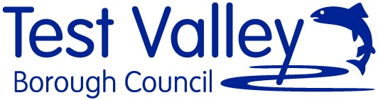

Project: Wellbeing at Mottisfont
Free: £3,000
Deadline: Monday 10 January 2021

Vision
Test Valley Borough Council in Partnership with the National Trust wish to commission two artists to collaborate on an environmental arts project for Mottisfont.
Mottisfont is an 18th-century building with a medieval priory at its heart, the beautiful house was transformed into a comfortable, neo-classical home in the 1930s.
The site specific commission invites artists to collaborate and create a project that explores the environments influence on wellbeing with a focus on inclusion and developing participatory audiences for Mottisfont.
We are interested to receive collaborative applications from artists combing two arts practices.
Aims
- To engage people who are visiting the house and gardens in creative arts activities and workshops.
- To explore how the rich variety of gardens and outdoor spaces combined with the creative arts can support wellbeing.
- To allow a space for artists to collaborate in designing participatory arts projects for specific groups
- To create work towards a final exhibition for the Stable Gallery.
Location
The project is focused at Mottisfont in the Test Valley and there is potential to explore their partner site of Foxbury as part of the project.
https://www.nationaltrust.org.uk/mottisfont
https://www.nationaltrust.org.uk/foxbury
Timeline
The recruitment will take place in January 2022 with the project starting for the spring 2022.
Fee
£3,000
This fee is based on £250 per day and is inclusive of project planning and time toward evaluations.
We expect that at least 8 days are focused on creative delivery.
How to Apply
Your submission should include:
- An outline proposal including suggestions of activities you envisage (not a full project plan at this stage) You should include details of your links to the Test Valley
- Proposed Budget
- Timeline
- Two referees who can be approached
- Examples of previous work of each artist (2 pages max) Please include an artist/organisation’s statement explaining how you will collaborate your work and/or artforms and what you hope to achieve by doing so
- Artists will be required to hold a DBS certificate and Public Liability Insurances.

Submissions will be shortlisted by a commissioning panel of TVBC and National Trust members of staff, shortlisted artists/organisations will be invited to give a presentation of their proposal on Wednesday 19th January 2022.

This should be sent to: Faye Perkins, Arts Officer, Test Valley Borough Council
by 10 January 2022.
Email: fperkins@testvalley.gov.uk

