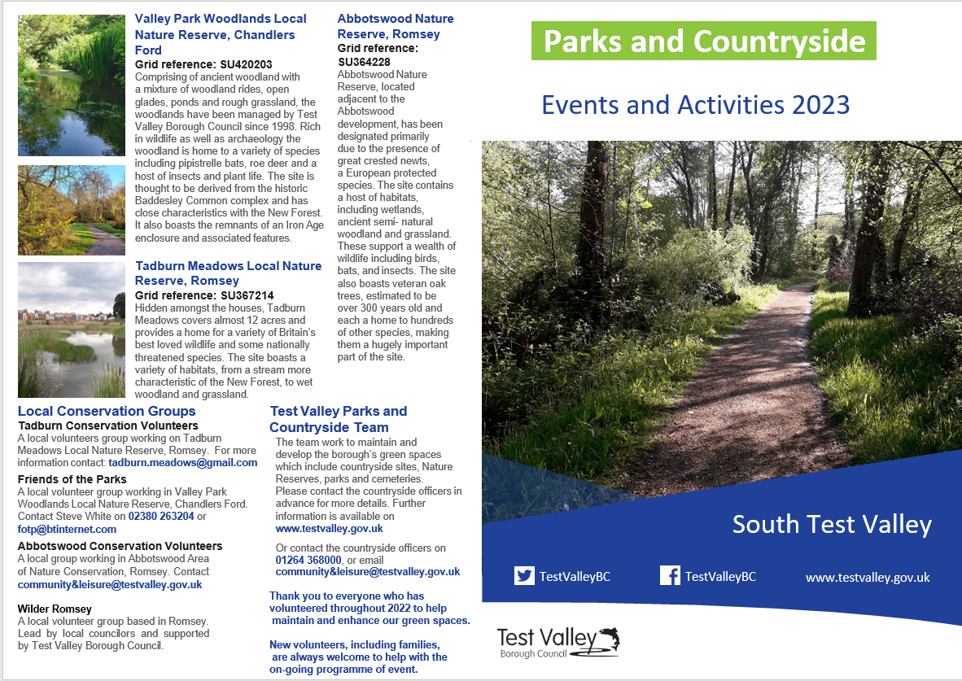
Parks and Countryside Events and Activities Guide 2023 South Test Valley
Date | Time | Task | Venue | Meeting Place
Sun 15th Jan | 10am – 12pm | Holly thinning & bonfire | Knightwood Copse | Violet Close Playground
Sat 28th Jan | 10am – 12pm | River Coppicing | Tadburn Meadows | Entrance to the reserve at Eight Acres
Sun 26th Feb | 10am – 12pm | Tree Planting | Skys Wood | Top of Morgan Le Faye
Sun 26th Feb | 10am – 12pm | Coppicing/scrub clearance | Tadburn Meadows | Entrance to the reserve at Eight Acres
Sun 26th Mar | 10am – 12pm | Coppicing | Zionshill East | Leisure centre
Sun 16th Apr | 10am – 12pm | Tree guard removal | Clothiers Copse | Top of Catmint Close
Sat 13th May | 10am – 12pm | General site maintenance | Tadburn Meadows | Entrance to the reserve at Eight Acres
Sun 14th May | 10am – 12pm | Boardwalk repairs | Little Covert | Leisure centre
Sun 18th Jun | 10am – 12pm | Heath management | Zionshill East | Leisure centre
Sun 25th Jun | 10am – 12pm | Himalayan Balsam Bashing | Tadburn Meadows | Entrance to the reserve at Eight Acres
Sun 9th Jul | 10am – 12pm | Bracken management | Tredgoulds Copse | Top of Yewberry Way
Sat 8th Jul | 10am – 12pm | Discovery day | Tadburn Meadows | Find us on site!
Sun 6th Aug | 10am – 12pm | Himalayan Balsam Bashing | Tadburn Meadows | Entrance to the reserve at Eight Acres
Fri 25th Aug | 7:45 pm onwards | Bat Walk | Tadburn Meadows | Entrance to the reserve at Eight Acres
Sat 9th Sept | 10am – 12pm | Himalayan Balsam Bashing | Tadburn Meadows | Entrance to the reserve at Eight Acres
Sun 17th Sep | 10am – 12pm | Coppicing | Skys Wood | Top of Morgan Le Faye
Sun 22nd Oct | 10am – 12pm | Coppicing | Skys Wood | Top of Morgan Le Faye
Sun 19th Nov | 10am – 12pm | Bramble/ditch Clearance | Tadburn Meadows | Entrance to the reserve at Eight Acres

Important Note
The practical tasks that we carry out on our Green Spaces and Nature Reserves can be strenuous, tiring and involve the use of hand tools that some people may find challenging. Please inform the co-ordinator leading the event if you have any medical conditions or concerns that could be a danger to yourself or other volunteers working around you. We reserve the right to restrict your level of participation in certain circumstances. All children under the age of 16 must be accompanied by a responsible adult.

