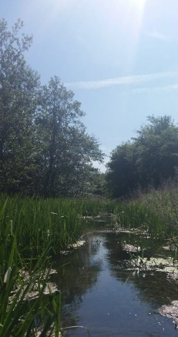
Anton Lakes LNR, Andover Grid reference: SU357466 Anton Lakes were formed as a result of gravel extraction. The
lake outflow is the headwaters of the River Anton. The springs, lake, river and meadows around the edge of the site provide a
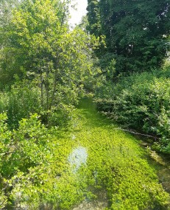
mosaic of habitats, including chalk grassland, watercress beds and water meadows. Cattle now graze throughout the summer months and help to support the diverse range
of wild flowers. Many birds can also be found on the lakes and streams including kingfishers and water rail.

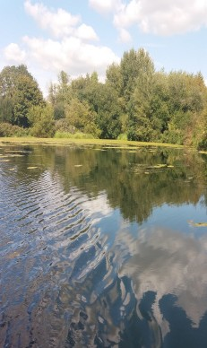
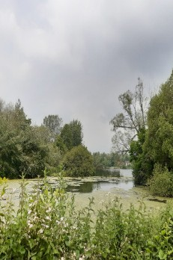
Ladies Walk, Andover Grid reference: SU369445 Located on the south eastern edge of Andover, Ladies Walk comprises of three moderately steep north facing meadows. The chalk grassland on site supports a diverse array of butterflies and other invertebrates, as well as
vertebrates such as common lizards and slow worms. The meadows are grazed throughout the summer to improve their sward structure. The Ladies Walk which boarders the site dates back to 1785.

Rooksbury Mill LNR, Andover
Grid reference: SU356443
Rooksbury Mill, also formed through gravel extraction and once a trout fishery, now plays host to a variety of wildlife including otters, water voles and kingfishers. Its mosaic of chalk grassland and riparian habitats provide a rich diversity of wildlife.
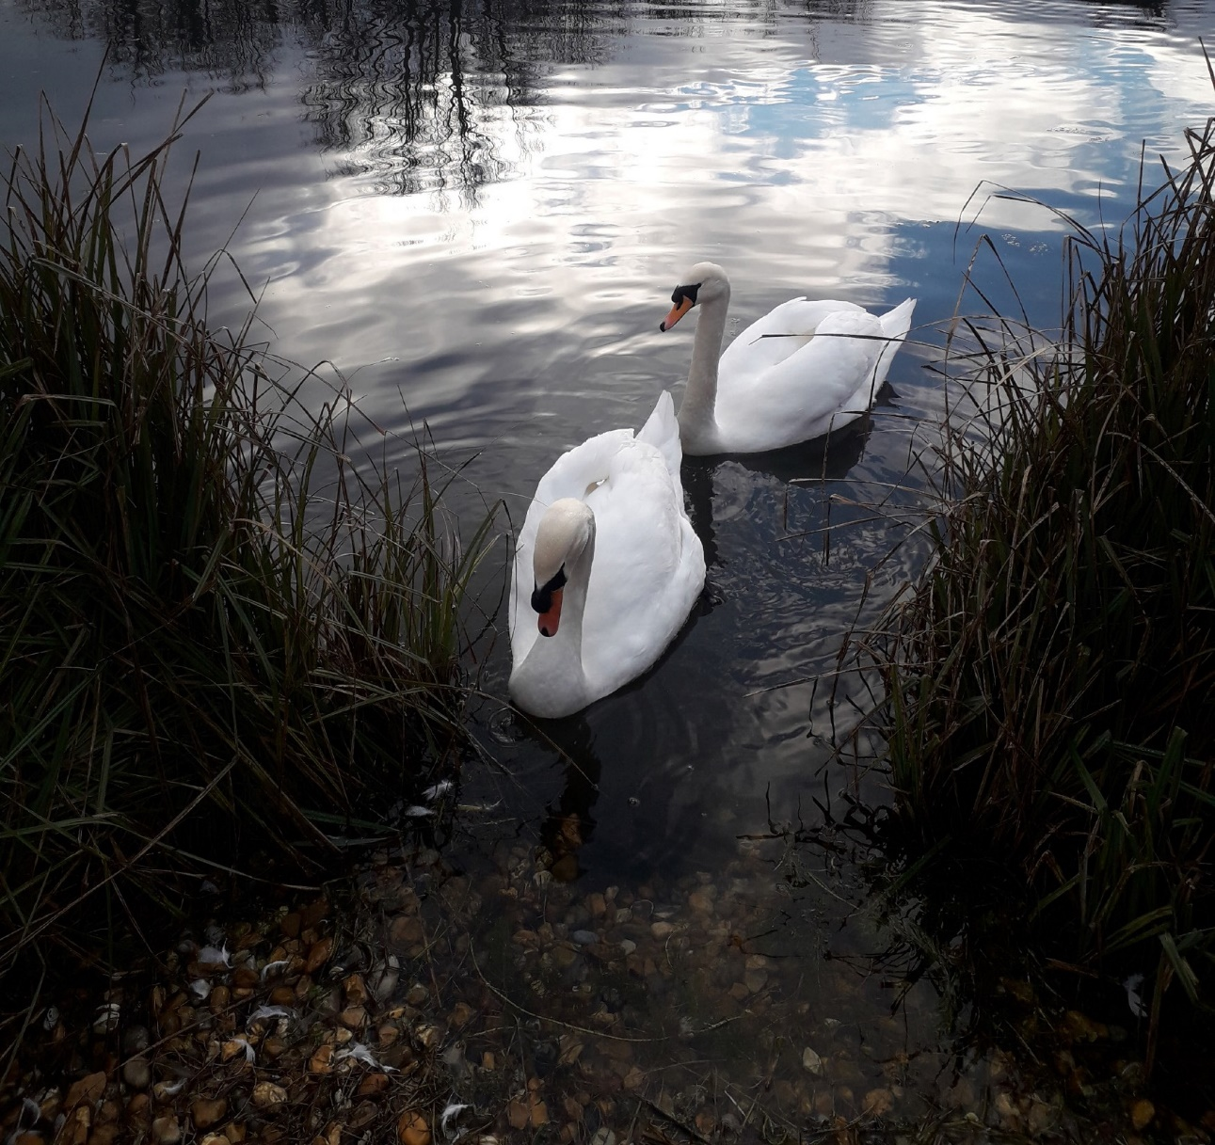
Harewood Common, Andover Grid reference: SU357466 Comprising of nearly 10 hectares of chalk grassland, Harewood Common is rich in wildlife and provides a refreshing contrast to the nearby Urban Park. Originally an agricultural field, the common backs onto the ancient woodland of Harewood Forest and is managed through grazing during the summer months. This creates an ideal
North Test Valley
TestValleyBC
TestValleyBC
www.testvalley.gov.uk
habitat for insects, birds and bats to thrive.

Ox Drove Meadow, Andover Grid reference: SU357466 Comprising of just over three hectares of chalk grassland, Ox Drove Meadow is made up of a gently sloping path which
encompasses the site. New trees planted around the site are helping to establish a robust hedgerow around its boundary which is important for the sites’ inhabitants which include a wide variety of birds and insects as well as the Hazel Dormouse which makes the site its home.
Parks and Countryside
Events and Activities 2024

Test Valley Parks and Countryside Team
The team work to maintain and develop the borough’s green spaces which include countryside sites, Nature Reserves, parks and cemeteries.
Please contact the countryside officers in advance for more
details.
Further information is available on www.testvalley.gov.uk
Or contact the the Countryside Officers on 01264 368000, or email community&leisure@testvalley.gov.uk

Local Conservation Groups The Anton River Conservation Association (TARCA)

Thank you to everyone who has volunteered throughout 2023 to help maintain and enhance our green spaces.
New volunteers, including families, are always welcome to help with the on-going programme of events.

 | Parks and Countryside Events and Activities Guide 2024 |  |  |  | North Test Valley
Date |  | Time | Task | Venue |  | Meeting Place
Sat 13 Jan |  | 10am – 2pm | Woody debris mattress creation | Anton lakes LNR |  | Car Park
Sun 28 Jan |  | 10am – 2pm | Scrub clearance | Ladies walk |  | Hedge end road playing field SP10 2DH
Sat 10 Feb |  | 10am – 2pm | Coppicing and ditch clearance | Anton lakes LNR |  | Car Park
Sun 25 Feb |  | 10am – 2pm | Watercress bed maintenance and scrub clearance | Anton lakes LNR |  | Car park
Sat 9 Mar |  | 10am – 2pm | Tree planting & tree guard removal | Harewood common |  | P20 Coop car park SP11 6TY
Sun 24 Mar |  | 10am- 2pm | Tree planting & tree guard removal | Harewood common |  | P20 Coop car park SP11 6TY
Sat 6 Apr |  | 10am – 2pm | Big litter pick, river clean and site maintenance | Rooksbury mill LNR |  | Car park
Sat 21 Apr |  | 10am – 2pm | Big litter pick, river clean and site maintenance | Anton lakes LNR & Wickes meadow |  | Car park
Sun 5 May |  | 4:45 am onwards | Dawn Chorus day | Rooksbury mill LNR |  | Car park
Sun 19 May |  | 10am – 2pm | Anton river clean | Behind ASDA |  | Car park behind ASDA
Sat 13 Jul |  | 10am – 2pm | Ragwort pull | Swattons |  | Charlton lakes BMX track car park
Sun 28 Jul (new date) |  | 10am – 2pm | Summer walk with optional lunch at the Oak, Smannell | Harmony woods paths around Smannell |  | East Anton Sports Ground car park SP11 6XU
Sat 3 Aug |  | 10am – 2pm | Free Family Discovery day | Anton lakes LNR |  | Car park
Sun 18 Aug |  | 10am – 2pm | Non-Native species removal | Rooksbury mill lNR |  | Car park
Fri 6 Sep |  | 7:45 pm onwards | Bat walk | Bury hill meadows |  | Car park
Sat 7 Sep |  | 7:45 pm onwards | Bat walk | Harewood common |  | P20 Coop car park SP11 6TY
Fri 20 Sep |  | 7 pm onwards | Bat walk | Rooksbury mill LNR |  | Car park
Sat 21 Sep |  | 7pm onwards | Bat walk | Anton lakes LNR |  | Car park
Sat 5 Oct |  | 10am – 2pm | Orchard day | Rooksbury mill LNR |  | Car park
Sun 20 Oct |  | 10am – 2pm | Riverbank cutting | Behind ASDA |  | Car park behind ASDA
Sat 2 Nov |  | 10 am – 2pm | Woody debris mattress creation | Anton lakes LNR |  | Car park
Sun 17 Nov |  | 10am – 2pm | Winter tasks | Rooksbury mill LNR |  | Car park
Sat 30 Nov |  | 10am – 2pm | Winter tasks | Rooksbury mill LNR |  | Car park

Important Note
The practical tasks that we carry out on our Green Spaces and Nature Reserves can be strenuous, tiring and involve the use of hand tools that some people may find challenging. Please inform the co-ordinator leading the event if you have any medical conditions or concerns that could be a danger to yourself or other volunteers working around you. We reserve the right to restrict your level of participation in certain circumstances. All children under the age of 16 must be accompanied by a responsible adult.

