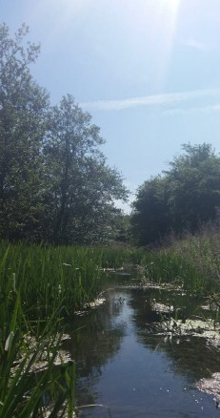**Anton Lakes LNR, Andover Grid reference: SU357466** Anton Lakes were formed as a result of gravel extraction. The

lake outflow is the headwaters of the River Anton. The springs, lake, river and meadows around the edge of the site provide a

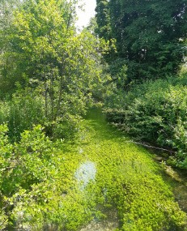mosaic of habitats, including chalk grassland, watercress beds and water meadows. Cattle now graze throughout the summer months and help to support the diverse range

of wild flowers. Many birds can also be found on the lakes and streams including kingfishers and water rail.

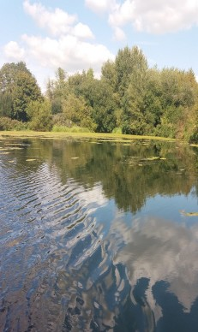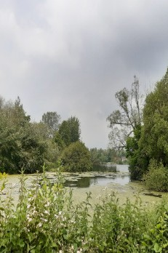**Ladies Walk LNR, Andover Grid reference: SU369445** Located on the south eastern edge of Andover, Ladies Walk comprises of three moderately steep north facing meadows. The chalk grassland on site supports a diverse array of butterflies and other invertebrates, as well as

vertebrates such as common lizards and slow worms. The meadows are grazed throughout the summer to improve their sward structure. The Ladies Walk which boarders the site dates back to 1785.

# Rooksbury Mill LNR, Andover

**Grid reference: SU356443**

Rooksbury Mill, also formed through gravel extraction and once a trout fishery, now plays host to a variety of wildlife including otters, water voles and kingfishers. Its mosaic of chalk grassland and riparian habitats provide a rich diversity of wildlife.

**Harewood Common, Andover Grid reference: SU357466** Comprising of nearly 10 hectares of chalk grassland, Harewood Common is rich in wildlife and provides a refreshing contrast to the nearby Urban Park. Originally an agricultural field, the common backs onto the ancient woodland of Harewood Forest and is managed through grazing during the summer months. This creates an ideal

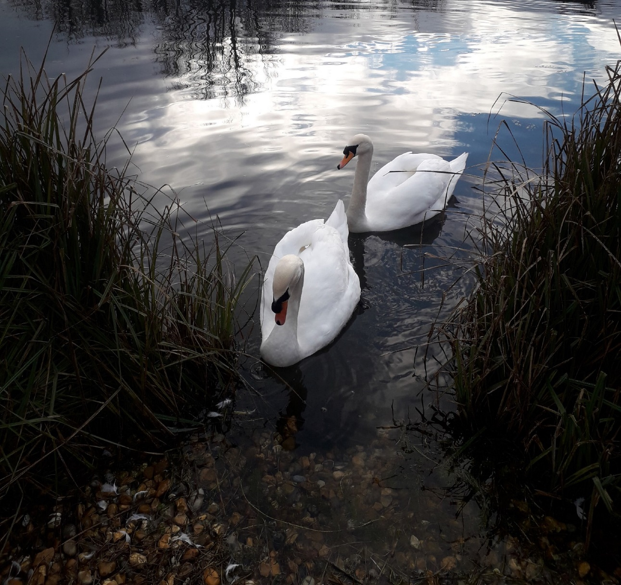

North Test Valley

TestValleyBC

TestValleyBC

[www.testvalley.gov.uk](http://www.testvalley.gov.uk/)

habitat for insects, birds and bats to thrive.

**Ox Drove Meadow, Andover Grid reference: SU357466** Comprising of just over three hectares of chalk grassland, Ox Drove Meadow is made up of a gently sloping path which

encompasses the site. New trees planted around the site are helping to establish a robust hedgerow around its boundary which is important for the sites’ inhabitants which include a wide variety of birds and insects as well as the Hazel Dormouse which makes the site its home.

**Parks and Countryside**

Events and Activities 2025

**Test Valley Parks and Countryside Team**

The team work to maintain and develop the borough’s green spaces which include countryside sites, Nature Reserves, parks and cemeteries.

Please contact the countryside officers in advance for more

details.

Further information is available on [**www.testvalley.gov.uk**](http://www.testvalley.gov.uk/)

Or contact the the Countryside Officers on **01264 368000**, or email [**community&leisure@testvalley.gov.uk**](mailto:community%26leisure@testvalley.gov.uk)

**Local Conservation Groups The Anton River Conservation Association (TARCA)**

## Thank you to everyone who has volunteered throughout 2024 to help maintain and enhance our green spaces.

**New volunteers, including families, are always welcome to help with the on-going programme of events.**

|  |  |  |  |  |  |  |
| --- | --- | --- | --- | --- | --- | --- |
| **Parks and Countryside Events and Activities Guide 2025** | | | | North Test Valley | | |
| Date | | Time | Task | Venue | | Meeting Place |
| **Sat 11 Jan** | | **10am – 2pm** | **Scrub clearance/tree thinning** | **OxDrove meadows** | | **Lockbridge road play area car park (SU393470)** |
| **Sun 26 Jan** | | **10am – 2pm** | **Hedge maintenance** | **Bury Hill meadows** | | **Bury Hill Car Park**  (**SU345431)** |
| **Sat 8 Feb** | | **10am – 2pm** | **Woody debris mattress and ditch clearance** | **Anton Lakes LNR** | | **Car Park (SU357467)** |
| **Sat 22 Feb** | | **10am – 2pm** | **Watercress bed maintenance** | **Anton lakes LNR** | | **Car Park (SU357467)** |
| **Sat 8 Mar** | | **10am – 2pm** | **Scrub clearance and Orchard maintenance** | **Ladies walk LNR** | | **Hedge End Road playing field SP10 2DH (SU371449)** |
| **Sun 23 Mar** | | **10am- 2pm** | **Scrub clearance and Tree planting** | **Ladies walk LNR** | | **Hedge End Road playing field SP10 2DH (SU371449)** |
| **Sat 5 Apr** | | **10am – 2pm** | **Big litter pick, river clean and site maintenance** | **Rooksbury Mill LNR** | | **Car Park (SU356444)** |
| **Sat 26 Apr** | | **10am – 2pm** | **Big litter pick, river clean and site maintenance** | **Anton Lakes LNR & Wickes Meadow** | | **Car Park (SU357467)** |
| **Sun 4 May** | | **4:45am onward** | **Dawn Chorus Day** | **Rooksbury Mill LNR** | | **Car Park (SU356444)** |
| **Sun 18 May** | | **10am – 2pm** | **Anton river clean** | **Behind ASDA** | | **Car park behind ASDA (SU362450)** |
| **Sat 14 Jun** | | **10am – 2pm** | **Path maintenance and tree guard removal** | **Harewood common** | | **P20 Co-Op car park SP11 6TY (SU390453)** |
| **Sat 2 Aug** | | **10am – 2pm** | **Free family discovery day** | **Anton Lakes LNR** | | **Car Park (SU357467)** |
| **Sun 10 Aug** | | **11am onwards** | **Summer walk with optional lunch at The Oak, Smannell** | **Harmony woods and paths around Smannell** | | **East Anton Sports Ground car park SP11 6XU (approx. SU373483)** |
| **Sun 17 Aug** | | **10am – 2pm** | **Non-Native species removal** | **Rooksbury Mill LNR** | | **Car Park (SU356444)** |
| **Fri 5 Sep** | | **7:45pm onward** | **Bat walk** | **Anton lakes LNR** | | **Car Park (SU357467)** |
| **Fri 19 Sep** | | **7pm onward** | **Bat walk** | **Rooksbury mill LNR** | | **Car Park (SU356444)** |
| **Sat 4 Oct** | | **10am – 2pm** | **Orchard day** | **Rooksbury Mill LNR** | | **Car Park (SU356444)** |
| **Sun 19 Oct** | | **10am – 2pm** | **Riverbank cutting** | **Behind ASDA** | | **Car park behind ASDA (SU362450)** |
| **Sat 1 Nov** | | **10am – 2pm** | **Woody debris mattress creation** | **Anton Lakes LNR** | | **Car Park (SU357467)** |
| **Sun 16 Nov** | | **10am – 2pm** | **Winter tasks** | **Rooksbury Mill LNR** | | **Car Park (SU356444)** |
| **Sat 29 Nov** | | **10am – 2pm** | **Winter tasks** | **Rooksbury Mill LNR** | | **Car Park (SU356444)** |

# Important Note

The practical tasks that we carry out on our Green Spaces and Nature Reserves can be strenuous, tiring and involve the use of hand tools that some people may find challenging. Please inform the co-ordinator leading the event if you have any medical conditions or concerns that could be a danger to yourself or other volunteers working around you. We reserve the right to restrict your level of participation in certain circumstances. All children under the age of 16 must be accompanied by a responsible adult.