**War Memorial Park Management Plan**

**2019 - 2025**

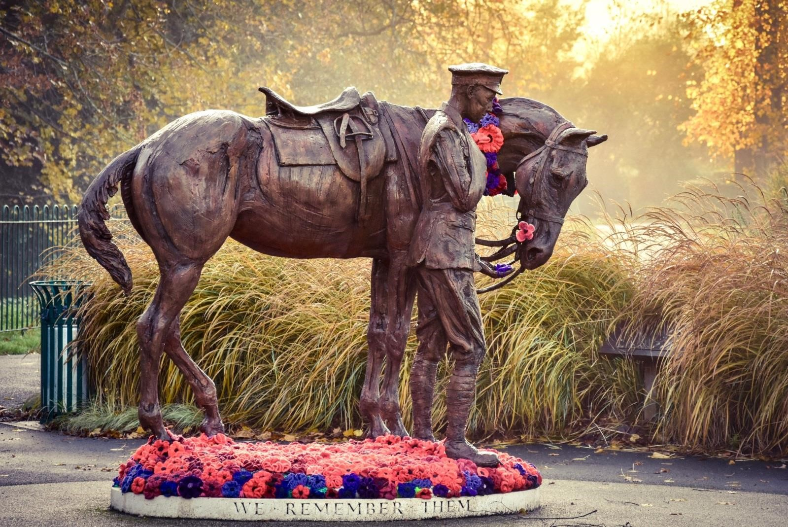

**Photograph credited to Natasha Weyers**



**Green Flag Winner 2008 - 2024**



# Acknowledgements

Thank you to the following people and organisations who have helped in the preparation of this management plan:

* Friends of War Memorial Park
* Romsey Future
* Romsey and District Society
* Romsey Bowls Club
* Sally Lamb and Park Café team

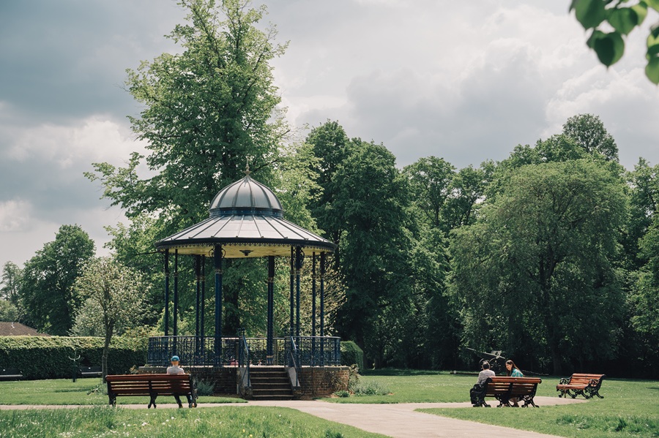

For further details, please contact: -

Community and Leisure Service

Test Valley Borough Council

Beech Hurst

Weyhill Road

Andover

SP10 3AJ

01264 368000

Community&leisure@testvalley.gov.uk www.testvalley.gov.uk

Contents

Acknowledgements 2

Section 1 – Introduction 4

1.1 Introduction 4

1.2 Our vision for Memorial Park 4

1.3 Aims 5

1.4 Specific Objectives for 2019 - 2025 5

Section 2 – Background 6

2.1 Memorial Park at a glance 6

2.2 A brief history 7

2.3 Policy context 9

2.4 Delivering the Council’s Corporate Objectives 10

Section 3 – What Happens Now? 12

3.1 Managing the Park 12

3.2 Maintenance 12

3.3 Resources 13

3.4 Finance and Budget 14

3.5 Working with the Community 14

3.6 Events 16

3.7 Health and Safety 17

Section 4 – Issues and Initiatives 18

4.1 Community Safety 18

4.2 Celebrating Romsey’s Cultural Heritage 19

4.3 Nature Conservation 20

4.4 A Sustainable Future 21

4.5 The entrance for the park and a setting for the Romsey War Horse Statue 22

Section 5 – Implementation: Monitoring and review 25

5.1 Monitoring and review 25

5.1 Action plan 2024- 25 26

Appendix 1 Map of Park 31

Appendix 2 Meet the team 32

Appendix 3 Ecology and Wildlife 33

Appendix 4 Health and Safety 38

Appendix 5 Example of minutes of Friends Meeting / Friends of Memorial Park Constitution 50

Friends of the Romsey War Memorial Park Minutes of Committee Meeting on 15th November 2018 Crosfield Hall, Romsey 50

# Section 1 – Introduction

## 1.1 Introduction

1.1.1 This is the eighth edition of the management plan for War Memorial Park, Romsey. The plan considers comments from the Friends of Memorial Park, park users, local organisations, and judges from the Green Flag Award, and those responsible for maintaining and managing the facility employed by Test Valley Borough Council.

1.1.2 The plan will steer the future direction of the parks management for the period January 2019 – December 2025. It is important that the management plan is not viewed as a rigid document but a framework for improvement and should not limit the development of the park if circumstances change. An annual review of the plan will ensure that objectives are assessed, amended, or removed to ensure focus and importantly, progress is maintained.

1.1.3 The first section of the plan sets out the vision for the park and our specific objectives for the five-year period to deliver this vision. A review of the progress made in Year Five is also included in the first section. The second part puts the park in its historical and policy context, given its characteristics and contribution to the quality of life of Romsey residents. Section Three and Four describe the current management arrangements and the initiatives currently underway to address challenging issues. The fifth and final section sets out our action plan for 2019 - 2024. How the management plan will be monitored and reviewed is also considered in this section.

## 1.2 Our vision for Memorial Park

*Our vision for the War Memorial Park in Romsey is for it to be a place where local residents and visitors of all ages enjoy a first-class green space and facilities. Following a visit to the park, residents and visitors will have had fun in a quality green environment and may have learned something of Romsey’s history and the Test Valley unique environment.*

## 1.3 Aims

1.3.1 We will achieve this vision by fulfilling the following aims: -

* Providing a safe and well managed park which can be accessed and enjoyed by everyone.

* Improving the range of facilities within the park whilst staying true to the park’s history.

* Minimising the impact on the environment by incorporating sustainable management practices and encouraging park users to adopt similar practices.
* Encouraging the community to use the park as an education resource to learn about horticulture and the environment.

## 1.4 Specific Objectives for 2019 - 2025

1.4.1 The following objectives have been developed through consultation with the

Friends of Memorial Park and from park user’s comments. The details are specified within an action plan as follows:

➢ Establish if any barriers to access exist and where possible remove these.

➢ Provide a clean and well-maintained park that balances horticultural excellence with ecology.

➢ Increase the opportunity for the local community to participate in the management and development of the park.

➢ Improve safety and the perception of safety in the park.

# Section 2 – Background

## 2.1 Memorial Park at a glance

2.1.1 Romsey War Memorial Park is located to the southwest of Romsey and is situated in The Meads and adjacent to the River Test. The park is a short distance from the town centre and sits just outside the Conservation area of Romsey Abbey.

**Land Owner** Test Valley Borough Council

**Ward** Romsey Abbey Ward

**Elected Members** Councillor Nik Daas (Liberal Democrat)

Councillor Sandra Gidley (Liberal Democrat)

**Size of the Park** 2.17 hectares

**Access & Car Parking** Car parking is located on street within The Meads. Additional parking can be found in Lortemore Place pay and display car park, a 5-minute level walk to the park. The entrance to the park can be accessed via The Meads and Saddlers Mill and offers level paths around and through the centre of the site – see site layout and location plan in Appendix 1.

**Park Facilities** ThePark Café is run by Georgie Gradidge and her team. Opening hours:

*November until February half-term: weekends only – 10.00 am - 4.00 pm\**

*February half-term: weekends – 10.00 am - 4.00 pm, weekdays – 10:00 am - 3.00 pm\**

*From February half-term until May half-term: weekends only – 10:00 am - 4:00pm\**

*May half-term: weekends – 10.00 am - 5.00 pm, weekdays –10.00 am - 4.00 pm\**

*May half-term until September: weekends only 10.00 am – 4.00 pm\**

*September: weekends – 10.00 am - 4.00 pm, weekdays - 10.00 am - 3.00 pm\**

*(*Times are subject to change; the Park Café website is updated regularly to reflect these changes)*

The public toilets with baby changing facilities and disabled toilets are open 364 days a year. Other facilities include a bowling green, children’s play areas, tennis courts, band stand, mature landscaping, seating, picnic area, public art, including the War Horse Sculpture and a Japanese gun.

**Cenotaph** The War Memorial stands in a prominent position just inside the main entrance gates in an avenue of lime trees. Services are held each year on Armistice Day as well as other important days of remembrance.

**Natural Environment** The River Test and one of its tributaries flows either side of the park. Fishing is controlled with permits issued by Test Valley Borough Council offices in Romsey.

## 2.2 A brief history

2.2.1 A park for Romsey was discussed many times before the First World War with letters of support to the Romsey Advertiser, notably from Mr Charles Moody the gunsmith in

Church Street. To this day Moody’s gun shop signage still exists; the building is now the town tourist information centre. Progress, however, was not made to create a park as local decision makers considered the expense simply not justifiable. However, after the First World War it was taken up again. Mr Charles Moody having lost a son in the war was a major supporter of a scheme to honour the fallen and 149 other residents who died in the conflict. It was decided that a park would be a fitting tribute to honour those who had fallen and be of great benefit to the townsfolk.

2.2.2 After much discussion about a suitable site, Corporation Meadow which had been a charitable gift to the town in the Middle Ages, was favoured. Corporation Meadow was a typical water meadow with various water ways across its surface as well as unstable underlying peat subsoil. Before creating the park, the ground was stabilised using hardcore, some of which was taken from the demolished Remount Depot at Pauncefoot Hill. The inspiration and park design were carried out by Mr Charles Dyson, the Rural District Surveyor aided by Mr Greenwood. The park was formally opened on 4th August 1920 by Major Spencer Chichester.

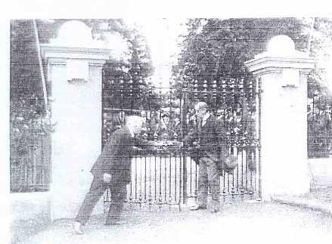

The official opening of War Memorial Park 1920

2.2.3 On the 22 June 1921 the Cenotaph commemorating the 149 local men who lost their lives in the First World War was unveiled. After World War Two the names of another 61 Romsey citizens lost in this war were added to the Cenotaph.

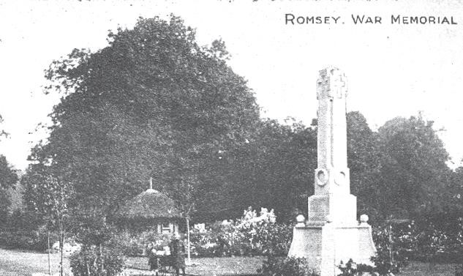

Cenotaph and original band stand with thatched roof

2.2.4 The park was founded by a dedicated Committee who passed it to Romsey Borough Council in 1924. In 1974 Test Valley District Council became responsible for the park.

2.2.5 Other notable events include the presentation by Lord Mountbatten of a Japanese 150mm field gun to Romsey on June 29th, 1946. The gun stood on the site of the former thatched bandstand until 2000, when it was removed for repairs and re-sited in the park close to the café.

2.2.6 In more recent years, the addition of the park café, replacing the kiosk initially built in the 1950s and toilets have catered for the increased visitor numbers. In 2001 the site of the former gun was transformed with the installation of a Victorian style bandstand. The structure was primarily funded by a local benefactor Miss Madge Saunders in memory of her father Alfred George Saunders, a local builder. Following its installation, a Bandstand Trust was formed which organises events in and around the bandstand throughout the year.

2.2.7 In 2015 a new entrance to the park was developed providing the setting for the new War Horse Sculpture.

## 2.3 Policy context

2.3.1 Memorial Park provides a valuable local amenity for the people of Romsey, and in a wider sense contributes to the delivery of policy at local and national level.

2.3.2 Good quality green space enhances urban living and can contribute to wider Government objectives such as improved health, reducing our carbon footprint and better community cohesion.

2.3.3 The Government’s vision for the renaissance of England’s green spaces seeks to ensure that the majority of local areas will have at least one quality green space with a Green Flag and over 75% of visitors will be satisfied with their local green space. The theme and targets set within this guidance have been embraced within the Council’s Green Space Strategy 2020 – 2030 which sets out our vision for the borough’s green spaces including Memorial Park. The specific objectives of the Green Space Strategy are:

* To respond to the increasing pressure for more (and more diverse) green space to meet current and future demand.
* Provide resilient spaces in the face of a changing climate.
* Connect green spaces to form part of an ecological network.
* Maintain safe and accessible green spaces.
* Encourage community participation in green space management.

2.3.4 A key objective within the earlier strategy was to achieve a Green Flag Award for Memorial Park and retain it. The Green Flag Award is the national standard for parks and green spaces in England and Wales. The award scheme began in 1996 as a means of recognising and rewarding the best green spaces in the country. It was also seen as a way of encouraging others to achieve the same high environmental standards, creating a benchmark of excellence in recreational green areas. War Memorial Park achieved the Green Flag Award in 2008 and has held this prestigious accolade each year since.

## 2.4 Delivering the Council’s Corporate Objectives

2.4.1 The Corporate Plan A Place for Everyone – Supporting our communities to thrive 2023 – 2027 has five key areas in which the authority will focus These are:

**Sustainability** – delivering lasting benefits for our communities.

**Connection** – building upon the identity, strengths, and ambitions of our communities.

**Environment** – a greener borough for our communities.

**Inclusion** – working together to create opportunities for our communities.

**Prosperity** – economic growth that impacts positively on our communities.

2.4.2 The management of War Memorial Park can be viewed as contributing to all five of these objectives through positive engagement with the community, providing a well-cared for and safe environment where people can meet and come into contact with nature.

2.4.3 A number of other strategies and partnerships influence the management of Memorial Park. Table 2 provides a summary of these.

Table 2 - Strategies, policies and plans influencing the management of Memorial Park

|  |  |
| --- | --- |
| **Council Strategy** | **Relationship with the management of War Memorial**  **Park** |
| Local Biodiversity Action Plan | The LBAP identifies key habitats and species which require management and protection. The management of the park will deliver long term objectives to enhance chalk river habitats as well as providing roosting sites for bats. |
| Borough Local Plan. 2011 - 2029 | Sets out the level and quality of open space throughout the borough and protects green spaces from development.  Policy ESN22 requires provision of Public Open Space for (development) proposals including a net increase in the number of dwellings where there is an identified deficit of  Public Open Space |
| Climate Emergency Action Plan | The Council declared a climate emergency in June 2020 with the ambition of reaching carbon neutrality before 2050. The climate emergency action plan sets out how we will reach this target. Management of the environment including green space and this park is integral to carbon emission reduction through appropriate management and sequestration efforts |
| Romsey Future | Romsey Future sets out a long-term vision for Romsey. It is an active partnership of many groups and organisations working together to build consensus and deliver on shared ambitions. The Strategy *A Vision for Romsey* *2022 – 2042* sets out the towns vision for the next 20 years |
| Green Space Strategy 2021-2031 | Outlines the strategic priorities and planned approach used to achieve and sustain these goals. Supported by an in-depth action plan that identifies the areas of focus which have been highlighted as areas of improvement within green spaces. |

# 

# Section 3 – What Happens Now?

## 3.1 Managing the Park

3.1.1 A number of Council services take an active involvement in the management of the park. Environmental Services take the lead on maintenance, Community and Leisure Service on strategy, development, and community involvement. The Property and Asset Management team (PAM) is responsible for all buildings. The services work closely and collaboratively to ensure management of this park is undertaken efficiently.

## 3.2 Maintenance

3.2.1 Grass cutting is carried out weekly between March and November. The frequency is weather dependent and is adjusted to ensure the grass does not reach a height of above 40mm. Litter is cleared daily to ensure the park is kept clean and litter and dog bins emptied. Additional operations are carried out throughout the summer period when use of the park is highest. The mixed waste ends up in the incinerator at Marchwood Energy Recovery Facility, Fawley. Electricity produced goes into the National Grid. (17 megawatts of energy is produced per annum). Marginal areas of the park are left to develop during the summer along the bank of the river to provide a more biodiverse grass sward for inspects and birds. These areas are cut twice yearly, and the arising removed.

3.2.2 Seasonal bedding schemes are an important feature in the park and provide year-round interest. Beds exist with displays refreshed twice a year in May and October. In line with the Council’s Green Space Strategy Strategic Priorities and as a result of recent changes in the local climate affecting ground conditions, new bulb mixes designed to withstand these conditions will be trialled and reviewed in combination with horticultural techniques in order to ensure longevity of bedding.

3.2.3 Shrubs are found throughout the park and are pruned at the correct time of year to promote new growth and good form. New planting has been carried out around the bandstand and in front of the Café and at the entrance of the park. It has also been refreshed along the long border against The Meads.

3.2.4 Maintenance of infrastructure including park toilets, the Café and bandstand is dealt with in partnership with the Council’s PAM team. In addition, the community and leisure team meet with the Café every quarter. A weekly report is recorded on the interior and exterior of the toilets which is actioned accordingly. Structures receive inspection on a six monthly / annual basis. Park furniture is inspected on a six-monthly basis with informal inspection almost daily with action taken as necessary to ensure risks are minimised. The annual restoration programme for park benches and bins is carried out during the winter months.

3.2.5 The tennis courts are cleaned once annually. To ensure limited chemical usage a section of fence is removed, and the courts swept to remove moss and leaves. Throughout the year the courts and nets are inspected weekly, and any leaf and woody debris removed when required. Nets are replaced when required.

## 3.3 Resources

3.3.1 The pressure on Council resources coupled with the high expectation of park users, means that we have to look for new and innovative ways to maximise our resources to ensure continuous improvement. We achieve this in the following ways:

* **By empowering the ground staff and gardeners.** Our dedicated team can make decisions on work programming which means areas of greatest need are prioritised rather than solely following a works schedule. The team also have direct access to a contingency budget which will enable works over and above routine activities to be funded.

* **Working in partnership with local groups and people.** This is a key resource we have to improve the park. Working with the Friends of Memorial Park as well as individuals has provided not only access to volunteer knowledge and support but has also led to sponsorship opportunities for projects and initiatives.

* **Accepting donations from local businesses and people.** Many projects completed within the park have only been possible following financial assistance from local businesses and individuals. Projects funded include the installation of the bandstand, memorial trees and benches, and wildlife refuges including bird and bat boxes. **Memorial bench donations have been so popular that we have had to pause the acceptance of new ones for the time-being.**

* **Section 106 contributions.** Should a development be approved within the ward which cannot feasibly include public open space an ‘off site’ contribution is collected to improve a space within the vicinity. Projects which have been recently completed in the park and part funded through contributions include the Park Café, the new entrance to the park and setting for the War Horse, and improvements to the Play Area.

## 3.4 Finance and Budget

3.4.1 The annual budget for maintenance is approved by Council in February each year and is summarised across the broad management areas in Table 3. To create a balanced budget Council services are required to find savings each year in order to bridge any gaps. Recent savings have not impacted directly on the parks management, but no increase has been received either. It is anticipated that we can expect a stand still budget in 2024/25.

**Table 3 - Outline revenue budget expenditure across management areas 2024/25**

|  |  |  |
| --- | --- | --- |
| **Management operation** | **Approximate expenditure** | **Outline minimum frequency of operation** |
| Grass cutting | £2,020 | 32 |
| Shrub bed maintenance | £1,910 | 9 |
| Seasonal bedding including maintenance | £8,670 | 30 |
| Hedge management | £735 | 2 |
| Play area inspection and maintenance | £2,704 | 52 |
| Tree management | £3,000 | Subject to survey |
| Planting – shrubs allowance | £500 | 1 |
| Cleansing | £11526 | 364 |
| Litter collection and bin emptying | £4,350 | When required / dependent on season |
| Building maintenance allowance | £1,000 |  |
| Parks development budget` | £1,000 |  |
| Income estimate | -£3,500 | £3000 from Café / £500 for memorial trees / |
| **Total** | **£33,915** |  |

## 3.5 Working with the Community

3.5.1 **Friends of Memorial Park** - The Friends of Memorial Park group was established in 2004 by the former town Mayor, Dorothy Baverstock. Since its inception, the group has played a pivotal role in guiding the direction of park enhancements and the development of this management plan. A copy of the organisation’s constitution can be found in Appendix 5. To ensure the sustained engagement of the group, TVBC regularly seeks opportunities to foster ongoing community involvement, thereby expanding the scope of both the site and the management plan.

3.5.2 **War Horse Committee** - A group of Romsey residents came together to mark the contribution horses made to the war effort. The Park has a close connection with the remount depot at Pauncefoot Hill. Romsey War Horse group raised a significant sum of money through events, public donations, and sponsorship andcommissioned the artist Amy Goodman to create a life size horse and sculpture which is positioned at the entrance to the park**.**

3.5.3 **Romsey War Memorial Archive** –This small group of military historians have, amongst other work completed a full detailed account of the history of those men who are listed on the town’s memorial. RWMA have engaged closely with local schools where children take on the name of one of the servicemen and look back through their lives. This work culminates with the children visiting the memorial in the park to locate the name.

3.5.4 **Romsey Bowling Club** –This Club is based in the heart of the park. The Club was set up in 1974. It is totally self-sufficient; the members maintain and fund the care of the green and the accompanying facilities.

It minimises chemical usage but the following outlines the maintenance schedule:

* Turf weeds are removed by hand as they appear or are spot treated with a selective herbicide (currently Verdone)
* Fungicides are used to control Fusarium and Dollar Spot. These are used on a cyclical basis to reduce resistance.
* Seasonal fertilizers are used as appropriate. The green is free draining so leaching of nutrients takes place. Seaweed extracts are used in conjunction with artificial fertilizers. Liquid iron or lawn sand is used to control moss.

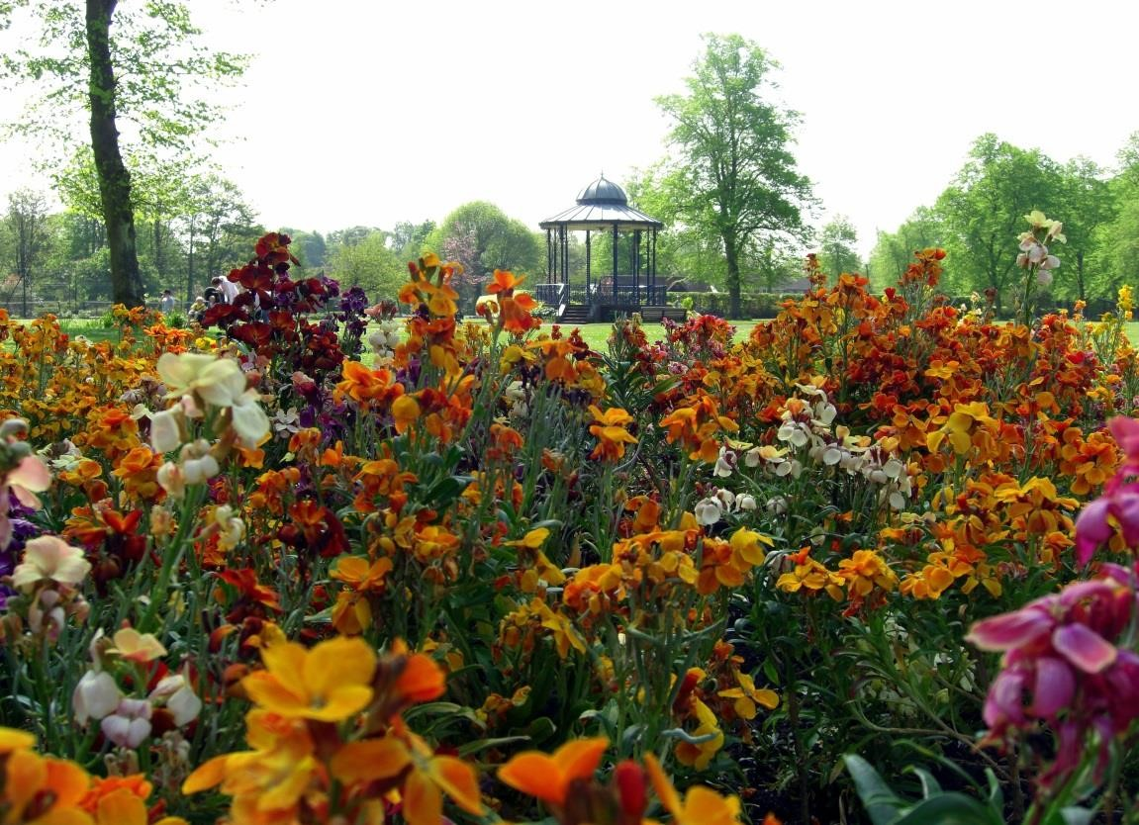

Bandstand in spring

## 3.6 Events

Throughout the year the park hosts a variety of events for the community. Up-to date details of all events in the park can normally be found on the Council website www.testvalley.gov.uk. A full list is also usually available at the entrance and café notice boards within the park.

3.6.1 The most notable event each year is Remembrance Sunday which provides residents the opportunity to pay their respects and remember those who have fallen serving their country and also to remember that this was the primary reason for creating the park.

3.6.2 Park events are all community led. These include the annual Mayor’s Picnic and Romsey

Carnival. Youth in Romsey host a live music event each year in July as part of the towns ‘Beggars Fair’ event. A dog show is hosted each year and a Wheelathon by Romsey preschool.

3.6.3 The Friends have also carried out the labelling of the significant trees in the park using aluminium tags. This is a useful and simple education tool for members of the public interested in the green environment, as QR codes are used on the labels.

3.6.4 **Romsey Bandstand Trust -** The Bandstand Trust are the custodians of the facility with bookings managed local by the team at Romsey Town Council. Weekly concerts are organised in the park throughout the summer with acts ranging from traditional brass bands to popular blues and jazz. The Trust is run by volunteers who not only organise and promote the events programme but also provide staff at each event. Events are supported by the fabulous team at the Park Café.

3.6.5Details of park and events are available on the Council’s website. Information is updated regularly at:

[Parks and Green Spaces - Romsey | Test Valley Borough Council](https://www.testvalley.gov.uk/communityandleisure/parksandgreenspaces/parks-green-spaces-romsey)

## 3.7 Health and Safety

3.7.1 In terms of other day to day issues: Risk Assessment inspections for the park are carried out and reviewed annually. These inspections include fences, paths, buildings, benches, and general park furniture. The Green Space Officer takes responsibility for any actions which arise from these inspections, and ensures they are completed within the designated timescale by the appropriate officer. Informal inspections of the park are carried out by the grounds staff on an almost daily basis. These visits are not recorded but if deemed to be high risk do result in immediate action.

3.7.2 The equipped children’s play area is inspected weekly by an operational Registered Play Inspector (RPI) qualified operative using the Play Safe data capture software. An example of this inspection form can be found in Appendix 4. Two annual inspections are carried out by an independent inspection team from the Royal Society for the Prevention of Accidents (ROSPA) as well as one of the Council’s insurers Zurich Municipal. The play area receives minor refurbishment works throughout the year and is scheduled for a full refurbishment in 2026/2027 subject to securing funding.

3.7.3 A strong link has been formed with Romsey Bowling Club which ensures that a joint approach to health and safety is followed along with consistency in assessing risks in the park. The Council has provided advice to the Bowling Club Committee on the storage of equipment and chemicals on site.

3.7.4 Tree Management –There are 117 trees in the park which are surveyed, and their condition logged on the Ezy Treev management database. The system of inspection is risk based with individual trees receiving an inspection depending on location, species, and condition. Works to trees is carried out by the Councils term tree contractor Gristwood and Toms. A walking inspection is carried out annually as well as adhoc inspections by the Tree Officer and park management staff when in the park. These inspections are unrecorded but result in immediate action if problems are identified. It is important to recognise the importance of appropriate management to retain trees but not lose sight of their value as a wildlife habitat. Tidy is not always the best option when considering all perspectives.

# Section 4 – Issues and Initiatives

## 4.1 Community Safety

4.1.1 A strong on-site presence is important to ensure park visitors feel safe and secure. A mobile group of grounds staff are on site regularly which provides a point of contact for visitors should any problems arise. This presence enables the staff to build a rapport as well as trust with regular visitors. Key Council staff who work in the park can be found in Appendix 2.

4.1.2 The Park Café provides a focal point where people congregate. This has views across the park and to the children’s play area. The team who manages the café are dedicated local people who have a strong connection with the park, and also within Romsey. This adds to the on-site presence.

4.1.3 The park is open 24 hours a day, therefore it would be wrong to give the impression that there are no issues at all with anti-social behaviour (ASB). In general incidents are minor. A summary of past issues and problems are as follows:

* Minor damage to café roof and storage shed
* Dogs being exercised on the tennis courts
* Occasional litter and dog fouling
* Minor ASB including drinking
* Swimming in the River Test / and associated perception of anti-social behaviour

4.1.4 Outside regular working hours the PCSO’s are instrumental in creating a safe place to visit in the later hours of the day and are quick to react to problems when they have resources.

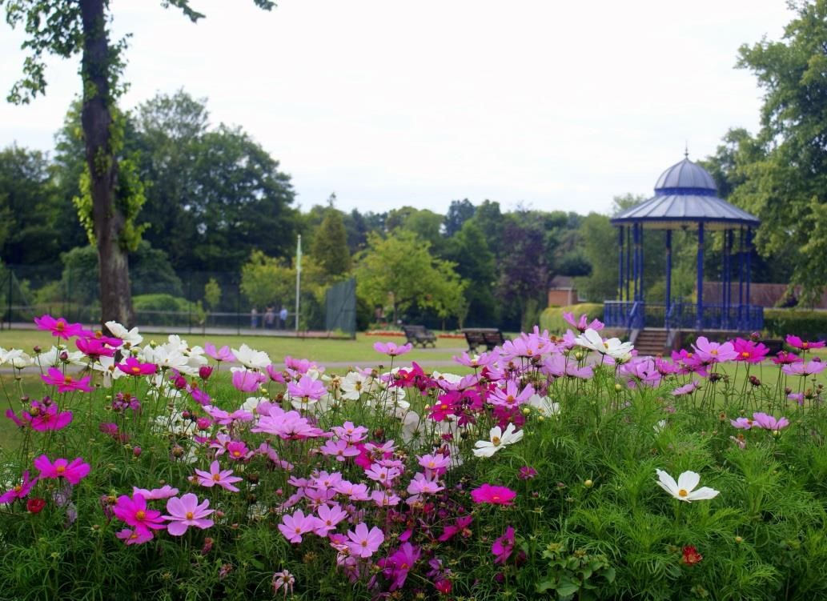

Bandstand in Summer

## 4.2 Celebrating Romsey’s Cultural Heritage

4.2.1 **Romsey Heritage Trail** -To celebrate Romsey’s long history as a market town and to promote its many features to visitors, a Town Heritage Trail has been created. The Trail marked with bronze markers in the pavements directs visitors through Memorial Park with the highlights here being the Cenotaph and Japanese Gun.

4.2.2 **The Japanese Gun** -The Park contains a Japanese World War II artillery piece, one of a pair captured by the British and brought back to Romsey by Lord Mountbatten of Burma. One was donated to the town by Lord Mountbatten and the other was retained in the grounds of his country estate, Broadlands. In 2001 the gun was restored by Test Valley Borough Council and repositioned in the southwest of the park, and in 2010 the wheels on the gun were repaired.

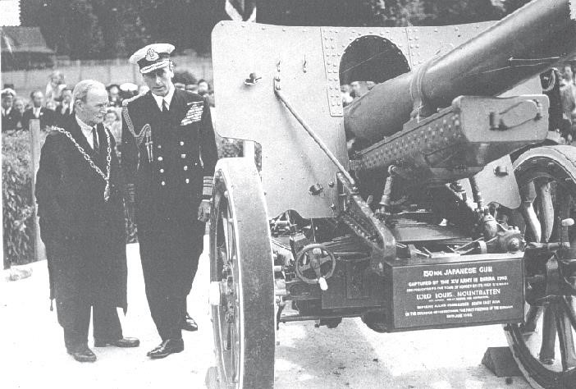

Lord Mountbatten and Mr Mayor presenting the Japanese field gun

4.2.3 **Romsey Charter Celebration 2007** -In 2007 Romsey Town Council celebrated the 400th anniversary of the Royal Charter. In 1607 King James I granted Romsey a Royal Charter, which gave the town Borough status. It also created the positions of Mayor, Aldermen and Burgesses as the Town Corporation. Furthermore, there was to be a High Steward, Town Clerk and Court Recorder together with two Sergeants-at-Mace. Later in the year the King visited the St Barbe family at Broadlands and planted mulberry trees (to feed silkworms), as part of his ambition to establish an English Silk Industry. In recognition of this historic event, a Mulberry tree was planted within Memorial Park. To further celebrate this important anniversary, the Friends of War Memorial park donated a bespoke iron tree guard with silkworm feature.

4.2.4 **War Horse** – In recognition of the contribution horses made to the war effort, and Romsey’s

connection to this with the location of the one of the country’s largest remount depots, a bronze sculpture of the War Horse ‘ Warrior’ was positioned in the park in 2015. The sculpture was funded through the work of the Romsey War Horse Committee with public donations and funding from public bodies.

4.2.5 **Poetry in Motion** -Bringing art, history and exercise together became a focus of the Poetry in Motion Project. The competition encouraged local people to contribute their favourite poem or original work with the best and most fitting permanently on display throughout the town including the park. The trail includes literary masterpieces from poets such as W.B Yeats, William Wordsworth, and Thomas Hood.

4.2.6 **Memorial Trees and Benches** –The Park is loved by people of all ages for many different reasons. Trees and benches offer a means of remembering loved ones, whilst enhancing the park and being of benefit to others. This has been particularly popular in recent years, so much so that we have temporarily closed applications for memorial benches as the park is now at maximum capacity.

4.2.7 **Welcoming Dog Walkers** -Dogs and their owners are welcome in Memorial Park but to ensure that visitors who are not so keen on canines can enjoy their visit we operate a “dogs on leads” policy. We are aware this is not always observed but we continue to work with dog owners. There is currently no legislation to enforce this but a Test Valley Borough Council working party is working towards this goal.

## 4.3 Nature Conservation

4.3.1 The role of urban green space in providing habitats for some of the UK’s most threatened species is now being recognised. Well managed parks can not only contribute to halting the long-term decline in species diversity but offer excellent opportunities to educate and inform the public on the part they can play in encouraging wildlife in their own gardens.

4.3.2 Memorial Park provides a variety of different habitats, but its potential is not yet fully realised. To rectify this, a series of management aims have been drafted to target key habitats within the park in balance with the sites recreational use. These are summarised in Appendix 3. Key habitats and species in the park are:

 **The River Test** -As one the best examples of Chalk River in Europe, the Test provides a home for a number of birds and fish as well as freshwater invertebrates. The river is regularly surveyed for fish which provide an indicator of the river’s quality. Future improvements to the river environment are scoped in the action plan with a project to recreate more natural banks along the river to produce suitable habitats for watervoles as well as the creation of an otter holt.

**Management of Deadwood** - Deadwood is left on the trees where it poses a low risk to public health. Where wood is removed deadwood piles are created at the base of the trees within the vicinity to provide an additional habitat for insects and bryophytes. Standing deadwood is left where it provides an additional habitat at the edges of the park.



**Trees and Bats** -Being situated adjacent to waterways in conjunction with the mature trees, the park provides an important feeding, and roosting habitats for bats. The park is used by several species of bat including the daubentons, noctule and common pipistrelle which use the site for foraging and summer roosting. Roosting pipistrelle bats have been recorded in the park.



4.3.3 To increase viable roosting habitat additional bat boxes have been erected in the park and now provide a variety of additional roost opportunities. A list of species using and living within the park has been compiled and can be found in Appendix 3. This list is not exhaustive and will be added to as we get to further understand this aspect of the park.

## 4.4 A Sustainable Future

4.4.1 Ensuring resources are maximised and waste is minimised is a core theme within the Council’s Corporate Plan, but translates locally to how we manage various aspects of park. Minimising waste and considering our actions at a local level will contribute to the global movement to minimise human impact on the environment and combat climate change. The Council has declared a climate emergency and is delivering work through a climate action plan to begin to decarbonise. The scale of the challenge means that all sectors of the community must be involved if we are to meet targets for reducing emissions and adapting to climate change. Our obligation to manage the park in a way to reduce energy consumption and waste is achieved in the following ways:

* + **Chemical Free Policy -** Since the drafting of the first Management Plan for the park in 2007, it has been the ambition to go ‘chemical free’. Since 2009 very limited chemicals no chemical have been applied in the park. The only area of the park where chemicals are still routinely used is the bowling club. The maintenance of the bowling green is undertaken by the Romsey Bowling Club. We have a close working relationship with the club and have advised them on the safe storage and handling of chemicals. This is an ongoing relationship which will provide updates for the club as standards and regulations change.

* + **Water Conservation -** With drier summers becoming more frequent a review of our bedding ordering has been carried out to ensure as little water is used as possible. This has resulted in a greater use of drought tolerant plants, such as geraniums, within the park. Reducing water usage is also considered within the public toilets where Hippo water bags have been placed within the cisterns. Each Hippo will save between 2.5 - 3.5 litres of water when fitted in an average cistern of 9 litres capacity.
  + **Local Plant Growing -** All bedding planted within the park is purchased on the south coast and delivered in one load.
  + **Recycling Green Waste -** Wherever possible, shrub pruning’s are used on site to act as weed suppressing mulch. All other material which cannot be used is taken off site to a central Veolia station and is then converted locally into ‘Pro Grow’ compost which is used as soil conditioner. This includes grass cuttings collected from the bowling-green which is stored in the Council green waste bags and recycled.

## 4.5 The entrance for the park and a setting for the Romsey War Horse Statue

4.5.1 On 3 July 2015, the Princess Royal unveiled the War Horse statue. Before the Unveiling Ceremony in the Park, the Princess Royal took the salute in the Marketplace, Romsey, where a military parade which had set off from Broadlands a little earlier, paused briefly before heading for the park. The parade consisted of soldiers from the Royal Veterinary Corps and the King’s Royal Hussars along with the King’s Troop, Royal Horse Artillery, the Household Cavalry, Royal British Legion officials, local Army, Air and Sea Cadets and Scouts and Guides led by Romsey Old Cadets Carnival. During her visit the Princess Royal was introduced to Phoebe Merrick, Chairperson and Royal Local History Group who presented a book on the War Horse to Princess Anne. The Princess was also greeted by Joey, the War Horse Puppet from the West End Theatre Show.

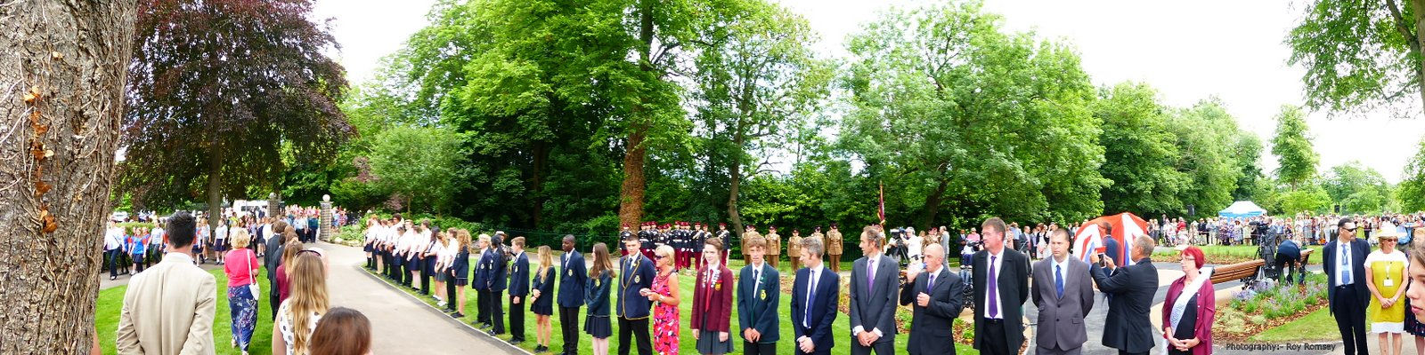

Local school children and the parks team wating for HRH Princess Anne

Amy Goodman presenting her work to HRH Princess Anne

4.5.2 This statue is of a war horse and his trooper from the First World War. It is made of Bronze Resin and the sculptor is Amy Goodman. Amy was inspired by the work of artist Lionel Edwards, Michael Morpurgo’s *War Horse*, and the story of Jack Seeley and his horse, Warrior.

4.5.3 The statue was paid for by voluntary contributions. It commemorates the role of Romsey in the Great War when an Army Remount Camp stood on Pauncefoot Hill, to the south-west of the town. The camp was erected in 1915 and demolished in 1920.

4.5.4 Romsey Remount Depot prepared horses and mules for military service. The camp consisted of more than 2000 men and could accommodate 5000 animals at any one time. Some horses came from England or Ireland, but many came from USA. Most of these were landed at Devonport and were collected by parties of soldiers from Romsey Depot. They were brought to Romsey by train and led through the narrow streets of the town and up to the camp. There they were given time to recover from their journey and then trained for military duties. Most of them were sent to Southampton where they were shipped to France.

4.5.5 After the war, the remaining horses at the camp were sold. Some buildings were sold, and the rest, together with the material used for roads in the camp, were broken up and used as hardcore to raise the ground on which this park was created.

4.5.6 Under the footings of the War Horse & Trooper Memorial are buried four horseshoes found on the battlefields of France, a Remount Depot Cap badge, and two terracotta horses made by local school children as part of a WW1 project.

For further information about Amy Goodman, the sculptor, go to [www.amygoodman.co.uk](http://www.amygoodman.co.uk/)

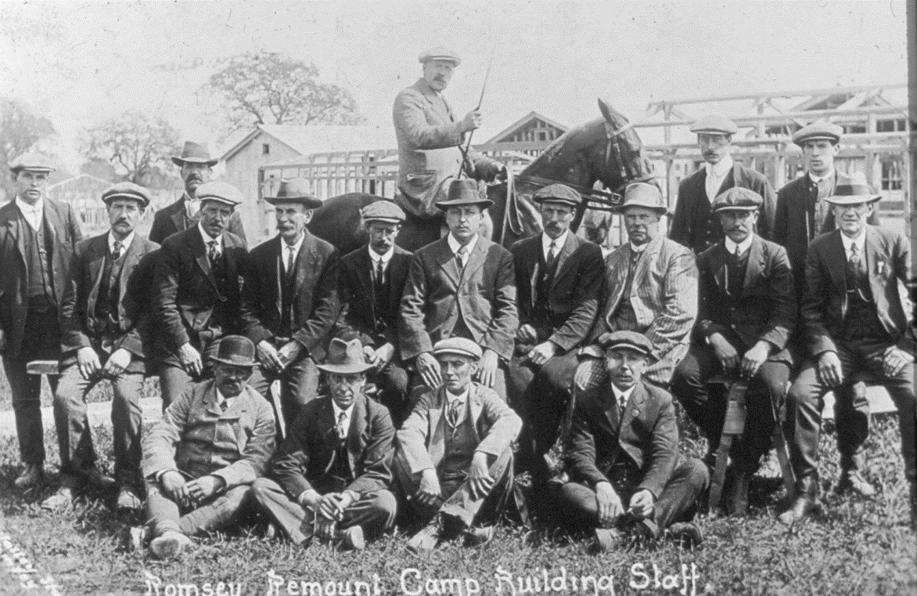

Building staff at Romsey Remount Depot, with the outlines of huts in the background

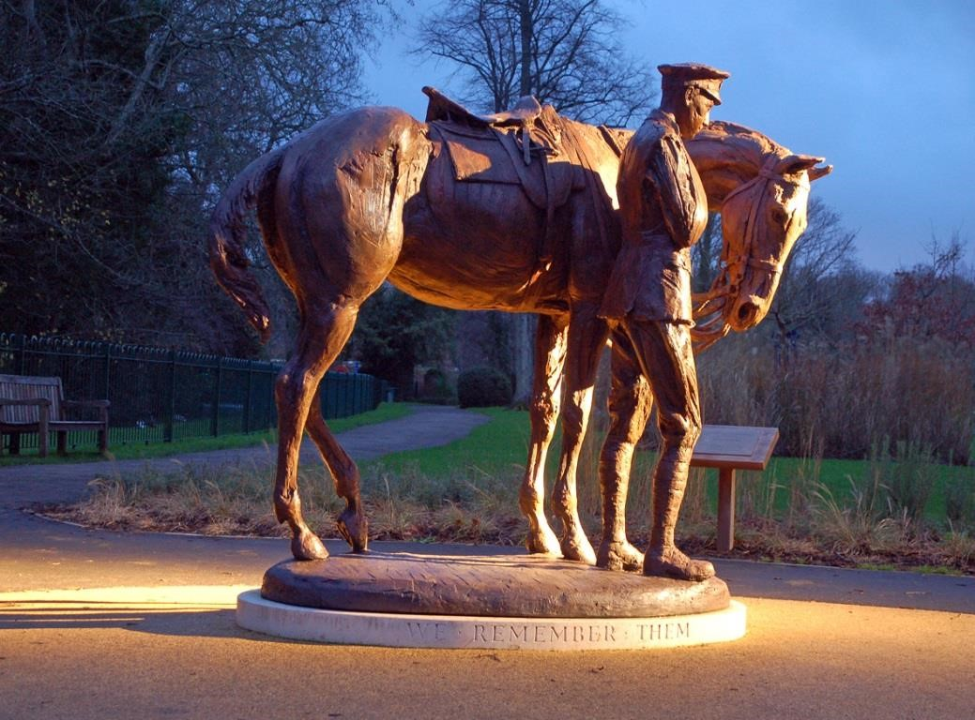

War Horse and Trooper

# Section 5 – Implementation: Monitoring and review

## 5.1 Monitoring and review

5.1.1 The management plan will treated as a live document which can be amended or changed to reflect new opportunities or changing circumstances. A formal review will conducted by the Friends of War Memorial Park and park management team.

5.2 It will be important to share with the public achievements but also where things have not been achieved and why. A summary or our past year’s performance against key objectives will be included each year in the management plan to ensure progress is tracked. Where our performance delivers objectives within other strategies this will be referenced.

## 5.1 Action plan 2024- 25

|  |  |  |  |  |  |  |  |
| --- | --- | --- | --- | --- | --- | --- | --- |
| **Management Plan Objective 1. - A Welcoming Place for visitors**  **Establish if any barriers to accessing the park exist and where possible remove these.** | | | | |  |  |  |
| **1** | **Action** | **Justification** | **Lead Officer** | **Performance Measure** | **Budget** | **Timescale** | **Date**  **Completed** |
| 1a | Encourage people back to the park through proactive marketing | To make best use of this community asset | GSO | Marketing material available/social media posts | Staff time | Ongoing |  |
| 1b | Refresh entrance by replacing litter bins (judges’ comments 2023) | To ensure the entrance to the park is not dominated by street furniture | GMM | Bins replaced | £1000 | Spring 2025 |  |
| 1c | Consolidate public information at the entrance to the park (judges’ comments 2023)  Greater use of park notice board to share information | Reduce clutter and ensure park users have easy access to important information. | GSO | Signage is replaced and information board kept up to date | £400 | Spring 2025 |  |

|  |  |  |  |  |  |  |  |
| --- | --- | --- | --- | --- | --- | --- | --- |
| **Management Plan Objective 2 – Maintenance, Conservation and Heritage**  To provide a clean, well maintained and sustainably managed park that balances horticultural excellence with ecology | | | | | |  |  |
| **2** | **Action** | **Justification** | **Lead**  **Officer** | **Performance Measure** | **Budget** | **Timescale** | **Date completed** |
| 2a | Apply for the Green Flag award | To provide a public indicator of standards within the park | GSO  FG | Application made to KBT, and judgement given | Staff time | Annual | Ongoing |
| 2b | To update ecological survey data to provide an accurate account of species using the park | To provide a quality indicator of habitats. Information on protected species and LBAP priorities to be reported to group | GSO  FG | Survey completed and recommendations worked into management plan. Information shared with  HBIC | Staff and volunteer time. | Annual survey | Ongoing |
| 2c | Review location of bird and bat boxes and re-site if  necessary | To ensure boxes are in the optimum location. Develop a monitoring programme and build up a record of current species using the park. Data to be supplied to HBIC | GSO  CO  FG | 1 Survey | Staff time | Annual survey |  |
| 2d | How can we keep the ducks while reducing impact on the park | Ducks are an important feature of the park, but the level of feeding increases the vermin problem and adds nutrients to the water course. This needs to be removed / reduced | GSO EA | Level of understanding is increased, and our visitors understand the benefit to the park and ducks by not supplementing feed | Staff time for initial project | Ongoing monitoring |  |
| 2e | Reduce chemicals used in the park and work towards ‘chemical free’ status in the public areas and the bowling club | To minimise the impact on the local environment by stopping the use of chemicals | GMM | Zero chemical usage in the public areas | Staff time | 2024 |  |
| 2f | Diversify the planting in the park and change areas where ground condition does not allow for formal planting | Improve range of planting in the park | GSO | A revised schedule of formal beds to be agreed | £1000 | Ongoing review |  |
| 2g | Refurbishment of field gun | Interim cosmetic improvements made during summer 2022 before programmed refurbishment | GSO | Heritage asset cleaned and budget secured for full refurbishment | £3000 | 2025 |  |
| 2h | Review litter bin provision in the park with the view to replace bins with recycling units | To increase the community’s ability to recycle when in the park | GSO  CAFÉ | Bins in place and recycling levels recorded | £1500 | Ongoing review |  |
| 2i | Improve the condition of the ground around the Iranian elm tree to ensure the compaction of the roots are minimised whilst creating an attractive environment for visitors | Scheme agreed | GSO  TO | Works completed | £1000 | 2025 |  |

|  |  |  |  |  |  |  |  |
| --- | --- | --- | --- | --- | --- | --- | --- |
| **Management Plan Objective 3 – Involving the community**    To increase the opportunity for the local community to participate in the management and development of the park | | | | | |  |  |
| **3** | **Action** | **Justification** | **Lead Officer** | **Performance Measure** | **Budget** | **Timescale** | **Date completed** |
| 3a | Involve local schools in park planting schemes | To foster greater public pride and ownership. Encourage greater participation | GSO | 1 event held (post covid) per year. | £500 per session plus staff time | Ongoing |  |
| 3b | Work with the Friends to ensure the group is representative of the park users | To increase the groups profile and boost membership | GSO | 1 event organised each year (post covid) | £500 | Ongoing |  |
| 3c | Continue to develop website to ensure easy access if information for visitors and potential visitors. | To provide visitors with current information on the park, ‘what’s on’ and how to get involved | PCM FG | Website hits and comments recorded both positive and negative  Website is to be updated and QR code to provided in the notice board | Staff time | Ongoing |  |
| 3d | Support community led third party events in the park | Increase the number of safe and accessible events which meet community needs | GSO | A range of events are held each year to promote the park | Staff time | Ongoing |  |

|  |  |  |  |  |  |  |  |
| --- | --- | --- | --- | --- | --- | --- | --- |
| **Management Plan Objective 4 – Safe and secure**    To improve safety and the perception of safety in the park | | |  |  |  |  |  |
| **4** | **Action** | **Justification** | **Lead Officer** | **Performance Measure** | **Budget** | **Timescale** | **Date completed** |
| 4a | Resurface and repaint tennis courts | To ensure a positive playing experience | GSO | Surface deteriorating | £21,000 | 2026 |  |
| 4b | Work with the Community Safety team and Animal Welfare Officer on proactive engagement with park users  Work in partnership with Hampshire Fire and Rescue to prevent life ring disposal in river | To reduce anti-social behaviour associated with young people swimming in the river in summer and dog walking on the tennis courts | CSO | Hot spot inspections to manage issues during the year | Staff time | Ongoing |  | |
| 4c | Capture digital inspection records for park assets | To ensure asset are free from defects | GMM | Records developed on PSS system | Staff time for data capture | Ongoing |  |

|  |  |  |
| --- | --- | --- |
| **PCM -** | **Parks and Countryside Manager** |  |
| **GSO -** | **Green Space Officer** |  |
| **CO -** | **Countryside Officer** |  |
| **GMM -** | **Grounds Maintenance Manager** |  |
| **HBIC -** | **Hampshire Biodiversity Information Centre** |  |
| **FG -** | **Friends Group** |  |
| **EA -** | **Environment Agency** |  |
| **CSO -** | **Community Safety Officer** |  |
| **SO -** | **Sports Officer** |  |

**TO - Tree Officer**

## Appendix 1 Map of Park

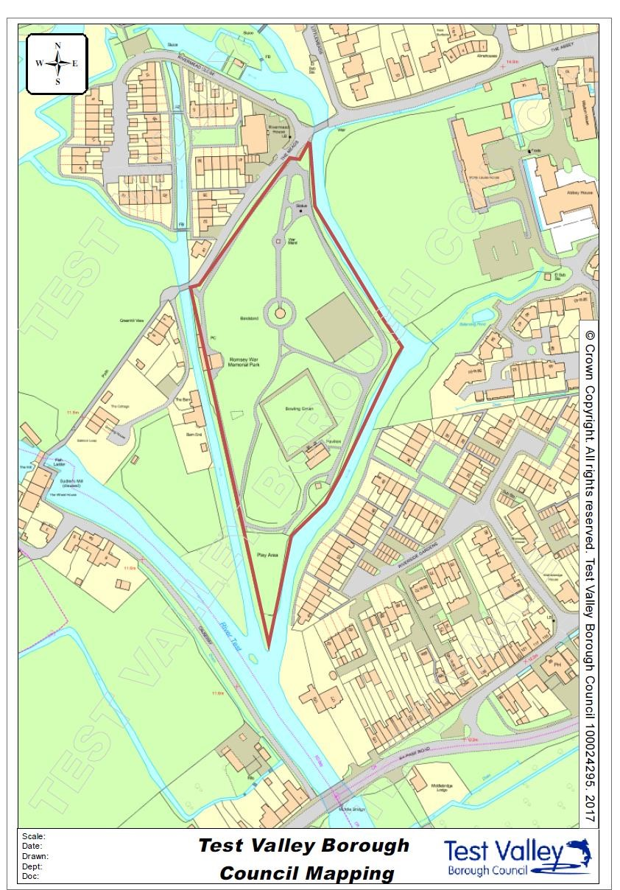

## Appendix 2 Meet the team

|  |  |  |
| --- | --- | --- |
| [User Photo](http://my2016/Person.aspx?accountname=TESTVALLEYBC%5CESBH) | NAME: Brett Hill  JOB TITLE: Street Scene Supervisor  TELEPHONE: 01264 368000  E-MAIL: bhill@testvalley.gov.uk    **Brett’s Role**  Brett manages the Street Scene Team in Romsey and sets the work schedule for the various crews who operate in this part of the borough. Brett is passionate about maintaining high standards in Memorial Park and works closely with the Parks and  Countryside team in Community & Leisure Service on improvements and new initiatives. | **Brett’s Qualifications:**  **Youth Training Scheme – Horticulture**  **City & Guilds 3 Examination – Horticulture**  **Competence in Chainsaw & Related**  **Operations (NPTC)**  **CAT & Genny Locator (Radiodetection)**  **KOMBI Operator**  **TP 150 PHM Woodchipper Operator**  **Woodchipper Operation (Landscape**  **Training)**  **Sprayer & Chemical Induction (Rigby**  **Taylor)**  **Mower Induction 1445/ 1905/ 900/9972**  **(John Deere)**  **Mobile Work Platforms (IPAF)**  **Safe Erection & Use of Aluminium &**  **Fibreglass Towers**  **Horticulture Phase 1 & 2**  **Amenity Horticulture Phase 2**  **Pesticide Competence PA1, PA6A**  **BABTIE Training Signing, Lighting &**  **Guarding**  **Hand Arm Vibration training**  **Risk assessment training**  **Working at heights training** |

|  |  |  |
| --- | --- | --- |
| Welcome to the Environmental Service | Test Valley Borough Council | NAME: Liam Oakes  JOB TITLE: Grounds Maintenance Operative  Liam is responsible for the day to day grounds maintenance operations within the Park.  (Liam was formerly a TVBC apprentice) | **Liam’s qualifications**  **Distinction achieved in 2021 in City and Guilds Horticulture level 2** |

## Appendix 3 Ecology and Wildlife

Appendix 3 - Ecology and Wildlife Management prescriptions

Long term aims for the site can be categorised into 4 Management Options:

1. - Active Conservation Management
2. - Monitoring and Research
3. - Education and Access
4. - Administration and Public Relations

|  |  |  |
| --- | --- | --- |
| Feature / Habitat | Management  Option | Outline Prescription |
| Meadow Management | A | 2 x cut grass and collect arising in Spring (before April) and Autumn (before late September) |
| Hedges | A | Cut mid-July and November and consider cutting 1 side per year |
| Tree Management / Orchard | A        C | Trees should be allowed to reach their ultimate form unless they pose a risk to public health. All tree work to be carried out to British Standards.    Labelling of key trees to aid specimen recognition.    Consider coronation cuts to promote habitat for bats.    Orchard - leave fruit on trees/ground as a food source for birds, insects, and mammals. |
| Deadwood | A | Standing deadwood to be maintained on trees where it poses no risk to the public. |
| Management of mixed borders | A | Perennial planting to be mixed with native shrubs and bedding. Perennials/grasses to be left to seed with only part clearance to create over-wintering habitat. |
| Management of riparian zone | A | Selective clearance of vegetation in August/September. Remove self-seeded trees/pollard (Willow) and monitor for non-native plants (Knotweed, Himalayan Balsalm). |
| Butterflies | B | Involve and support residents with butterfly transects on site between April and September to compile baseline information. Send results to Butterfly Conservation. |
| Dragonflies & Damselflies | B | Support transects of dragonflies on site between May - September to compile base line information. Involve British Dragonfly Society and other local naturalists. |

|  |  |  |
| --- | --- | --- |
| Birds | B | Conduct a Common Bird Census (CBC) with assistance from British Trust for Ornithology (BTO) members and residents. |
| Birds | B | Monitor bird boxes from February - July. Ensure boxes are cleaned and are free from nesting material before November. (Caution needed regarding bat use). |
| Mammals | B | Record and note species seen by residents / staff to compile database. |
| Water voles / otters | B | Monitor natural bank habitat and woody vegetation to the southeast boundary all year. Consider value of otter holt. |
| Bats | B | Monitor foraging and roosting activity from April - October. Bat boxes to be checked. |
| Fish (freshwater environment) | B | EA survey River Test to monitor fish populations (Salmonoid redds - November survey). |
| School Involvement | C | Involve local children in projects on site. |
| Interpretation of features | C & D | Commission temporary interpretation boards for meadow area, orchard, and area adjacent to river. |
| Increase public awareness | D | Through interpretation boards, guided talks, and work parties |

**Species list – updated summer 2021**

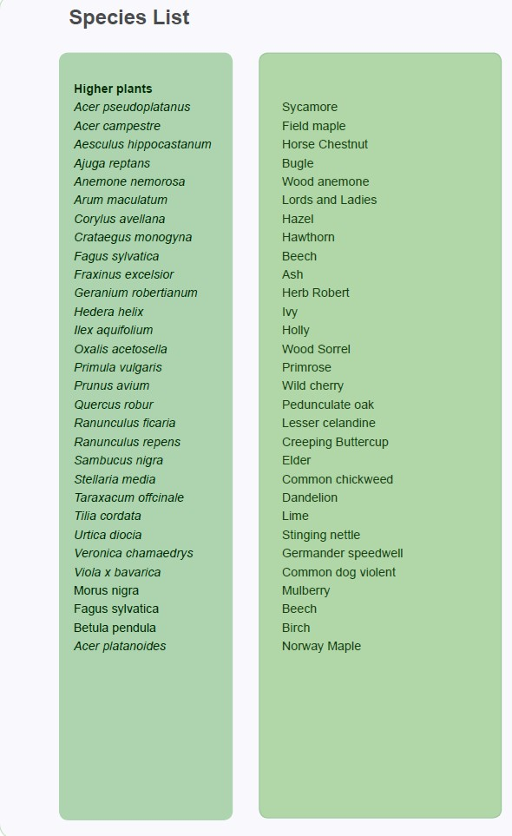

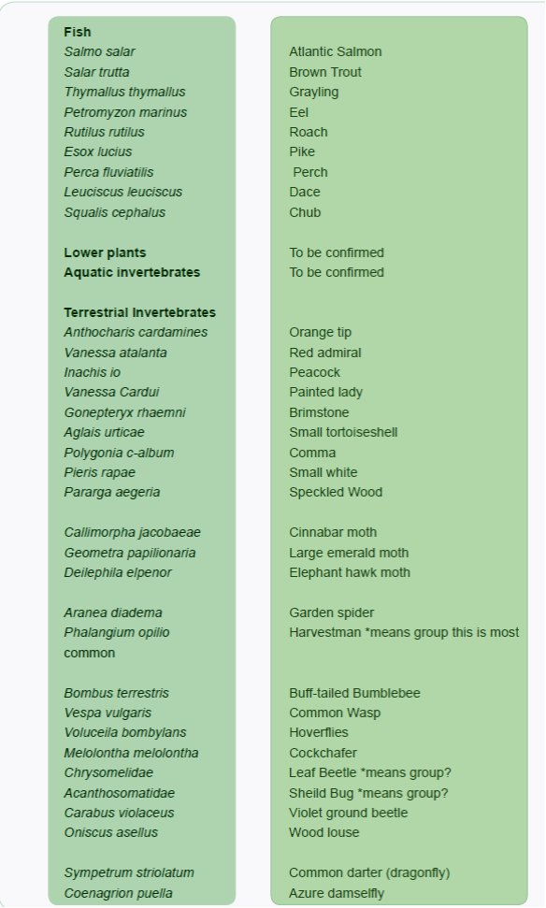

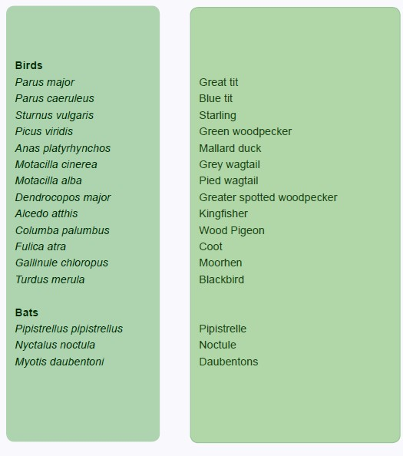

## Appendix 4 Health and Safety

As outlined in section 3.7 Health and Safety is of paramount importance when working within the park. To ensure continuity the following safe operating procedures have been drafted and are followed by staff when working in the park. A list of our safe operating procedures is below. An example of a full Safe Operating Procedure follows the list.

Safe operating procedures

* Post hole boring
* Safe use of strimmers
* Safe use of hedge trimmers
* Ride on and pedestrian rotary mowers
* Safe use of ladders
* Roller, scarifying, spikers and lawn edging
* Low pressure jet wash
* Safe handling of sharps
* Use of company vehicles
* Snow and ice gritting
* Use of petrol blowers
* Convenience cleaning
* Safe application and use of herbicide, pesticide, fungicide and fertilizer
* Mechanical channel and footpath sweepers
* Litter picking and manual sweeping
* Trailer use
* Transport of and safe use of wood chippers
* Use of hand tools
* Chainsaws
* Planting and staking
* Stump grinders
* Rotavators
* Installation of bins and benches
* Dog bin emptying
* Litter bin emptying



Environment Services

Safe Operating Procedure

|  |  |  |
| --- | --- | --- |
| **Safe Use of Ride-on &**  **Pedestrian Rotary Mowers** | | **SOP 05** |
| **Key Risks:**   * **Lacerations** * **Eye injuries** * **Traffic accidents** * **Health problems** * **Fire / explosions** * **Vehicles overturning** | | |
| **PPE:**   * **Safety footwear** * **High visibility clothing (including wet weather clothing)** * **Safety goggles/glasses/face shield** * **Gloves** * **Overalls** * **Ear defenders** | | |
| **Precautions** | | |
|  | * Routine maintenance schedule in place.      * Mower checked by operator before use.      * Guarding on blades, belts & chains.      * Operated by fully trained individuals only.      * Dynamic assessment of area completed before work begins. | |
|  | * No loose clothing/jewellery/long hair.      * Extra care to be taken on slopes.      * Power switched off before clearing blockages.      * Power switched off in close proximity to animals & children. | |
|  | * Spare fuel kept securely in suitable containers.      * Funnel used for re-fuelling.      * Fuel spills cleared immediately.      * No smoking.      * Engine switched off when re-fuelling. | |

**SAFE USE OF RIDE-ON AND PEDESTRIAN ROTARY MOWING MACHINES**

1. **Hazards**

* 1. Contact with the revolving blades.

* 1. Contact with flying objects which have been thrown up by the blades.

* 1. Entrapment & ‘drawing in’.

* 1. Fuel leaks, refuelling, and/or by the build-up of grass, particularly on the exhaust manifold.

* 1. Ingestion and poisoning through the lead in the petrol being absorbed through the skin.

* 1. Dermatitis should petrol be used to clean the skin.

* 1. Asphyxiation or build-up of exhaust fumes in confined spaces.

* 1. Traffic accidents should a vehicle mount a kerb, or you step into the road.

* 1. Noise.

* 1. Risk of overturning when going across steep slopes.

1. **Causes of Accidents or Injuries**

* 1. Lack of experience, training, and instruction.

* 1. Horseplay, fooling around and general lack of care and attention.

* 1. Failure to wear PPE, particularly safety footwear and high-visibility clothing.

* 1. Failure to maintain the mowers properly (particularly the blades), using incorrect or unsuitable parts and materials, coupled with the failure to fit the guards and grass boxes provided.

* 1. Adding fuel whilst the engine is running and it spilling over the hot exhaust manifold. Smoking whilst re-fuelling or mopping up spillages. (Remember that fuel can leak or be spilt if the mower is turned on its side or upside down.)

* 1. Making adjustments to the engine without it being switched off and unplugged. (Remember that the blades can take some time to stop revolving once the power has been switched off.)

* 1. Failing to look out for, and remove objects which can be thrown up such as stones, bricks, bottles, and sticks which may be in the mowing area.

* 1. Pulling the mower towards you, instead of pushing it, with the result that the mower may fall on top of the operator if they slip or stumble.

* 1. Mowing on a steep slope, especially on wet grass.

1. **Precautions – General**

* 1. Only authorised persons who have been specially trained or who are undergoing training, are allowed to use rotary grass cutting machines.

* 1. You must wear suitable protective clothing when operating mowing machines; Safety footwear & high visibility jackets are mandatory.

* 1. Learn the controls of the mower before you physically operate it. The instruction manual should be studied, and you should know how to quickly stop the machine in an emergency.

* 1. Before starting work, the machine must be carefully checked. Guards for the blades, gears, chain & sprocket, vee belt drives and any shafts must be in place. The grass box must be fitted, where provided, since this also acts as a guard. Check the operation of the clutch and emergency stopping controls, and check that the wheels are in sound condition. Check the blades carefully for wear or damage as damaged blades and worn securing bolts are major hazards. Clean off any grass on or in the machine, especially around the exhaust manifold and the cooling fins. Finally, check that there are no fuel leaks from the tank, fuel lines or carburettor. Report any defects to your supervisor.

* 1. When taking the mower on a trailer or in a van, ensure that it is either tied or wedged in position to prevent it moving and that the fuel is switched off. Ensure that the machine’s engine is switched off when loading or unloading the machinery from the vehicle or trailer. If you have to lift a pedestrian mower, use the safe lifting techniques explained to you and/or get help.

* 1. Never carry more than 50 litres of diesel fuel or 10 litres of petrol in any vehicle or trailer. Check that the caps are tight and that the containers are suitably secured for transport.

* 1. Never smoke or handle sources of ignition when pouring fuel or mopping up spillages. Check that the fuel type grade and mixture is correct and that it is in the properly labelled container. Never re-fuel in a confined area. To avoid spilling petrol, particularly on the exhaust manifold, always use the spout provided with the container (use a funnel if this has been lost). Clear up any spillages. When refuelling the mower, first switch off the motor, allow the engine to cool down and disconnect the spark plug. Remove any grass cuttings and make a visual check on the integrity and security of the blades and mountings. Only tip up a pedestrian mower when the tank is empty to prevent petrol leaking from the vent pipe or filler cap.

* 1. Keep the fuel container in a safe place, preferably in the shade or under cover, well away from any sources of ignition. Keep it clear of children and other persons, and in a spot where you can easily keep an eye on it. When you move some distance away, switch off the mower, collect the fuel container and again place it in a safe place local to the work area.

* 1. Before work begins, place warning signs at all access points of the site and ensure you are wearing the correct PPE. Before actually starting, disengage the blade and drive clutches, check for fuel leaks and refit the spark plug lead. Check that the throttle and choke levers are in the start position. Once the engine has warmed up, check that the clutch disengages immediately the throttle is set to idle, and that the motor stops once it is switched off. If neither of these occurs, do not use the mower until the defect has been rectified.

* 1. You must wear the ear muffs provided.

* 1. Beware of the run down time of the blades after the motor has been switched off.

* 1. You must stop the engine when:

* + 1. Adding fuel.

* + 1. Cleaning the mower or freeing blockages.

* + 1. Making adjustments to the machine unless these are related to its running, e.g. adjusting the choke or throttle settings.

* + 1. Crossing roads, gravel paths and other hard surfaces etc. when using a pedestrian mower.

* + 1. There is immediate danger i.e. children or animals in the immediate vicinity.

* + 1. In a confined space, since the build-up of carbon monoxide will be fatal within a short period of time.

vii. Leaving the mower unattended. You must also completely remove the spark lead or otherwise immobilise the engine so as to prevent other persons starting up the mower. Turn off the fuel tap.

viii. You hear unusual noises coming from the mower or blades. If, after investigation, the noises continue or you can see that a serious condition has arisen, switch off the engine immediately and do not use the mower until the defect has been rectified.

ix. Loading and unloading the mower onto/off from a vehicle or trailer.

* 1. When loading/unloading a pedestrian mower from a vehicle or trailer always push the mower away from you; never walk backwards with it or pull it as the mower may fall on top of you should you slip.

* 1. Always keep a look-out for objects on the ground which could be thrown out violently, could become wrapped around or could damage the blades, e.g. wire and string, stones, bricks, sticks etc. Always pick up such objects and place them in a safe place where they cannot cause a hazard to subsequent mowing operations.

* 1. Be very careful when mowing over humps or dips so as to avoid the blades over-speeding or biting into the ground.

* 1. When you are operating a pedestrian mower on slopes or wet grass, be extra careful with your footing. Wherever possible on a slope, wear spiked overshoes and stand at the top of the slope above the mower, moving the mower with a rope if necessary. If this is not practical, then some other means such as a scythe or strimmer must be used to cut the grass safely. In this way, the mower can never overrun the operator and the blades should stop revolving should the operator lose control.

* 1. Do not over speed the engine or alter the governor setting since excessive speed is dangerous and can lead to the blades flying out. This will also shorten the life of the mower.

* 1. Remember that rotary mowers can and do inflict serious injuries, mostly to those persons who are careless or fail to treat them with respect. Never pick up or carry a pedestrian mower when it is in operation or attempt to make any adjustments whilst the blades are still revolving. If you have to leave the mower unattended, remove the plug lead or otherwise immobilise it, and remember to turn off the fuel tap.

* 1. Never swallow petrol or blow into the fuel line, carburettor or fuel tank since the products in the petrol can cause poisoning, even when only minute quantities are involved.

* 1. If you have a serious breakdown which you cannot resolve yourself, notify your Supervisor or take the mower back to base.

* 1. When you have finished mowing, remove the warning notices and turn off the fuel supply before leaving the site.

**REPORT ANY DEFECTS IN YOUR VEHICLES, EQUIPMENT OR SAFETY APPLIANCES AND ANY**

**OTHER HAZARDS DIRECTLY TO YOUR SUPERVISOR. CONSULT HIM/HER IF YOU ARE IN ANY DOUBT WITH REGARD TO POSSIBLE HAZARDS OR THE PRECAUTIONS NECESSARY TO OVERCOME THEM.**

PSS+ Live Digital inspection form

## Appendix 5 Example of minutes of Friends Meeting / Friends of Memorial Park Constitution

### Friends of the Romsey War Memorial Park Minutes of Committee Meeting on 15th November 2018 Crosfield Hall, Romsey

**In attendance -** Dorothy Baverstock (Chair), Clive Collier, Noel Preece, Alan Stanley, Diane Smith (representing the Bowls Club) Steve Beasley (Secretary).

**Apologies for Absence -** Apologies were received from Jean Stone.

**Minutes of Meeting dated 22nd February 2018** were agreed as a true record.

**Matters Arising •** Clive Collier asked if additional benches had been considered for the children’s play area, Noel Preece confirmed this had been considered but felt there was insufficient space in that area.

* There has been interest from family members to have benches in the park in memory of their relatives which is being followed up.
* The secretary confirmed that Nick Chivers a local resident had been approached and was interested in joining the committee, the timing of the meeting had been put back to encourage working age people to be able to attend. (**Secretary Note** – Nick Chivers and Richard House are both on the mailing list for meetings)
* The managing of a table tennis table was not supported by the café tenants.
* It was confirmed the Tree QR Codes were sent to Noel Preece.
* The supply of tree labels (incorporating the QR codes) and the fixings had been funded by TVBC.
* The Rotary Club of Romsey Test, Community Service Committee to be approached to fund planting. (**Secretary Note** – Post meeting Noel Preece provided the secretary with **following text** to make an application, which has been endorsed and sent to the Rotary Club for consideration.)

*“I would be grateful if Romsey Rotary would consider a request for £300 to purchase plants to fill the gaps in the Long Border in Memorial Park.*

*Some rejuvenation of the border has recently taken place but there are gaps in the planting following the long hot summer.*

*This is a border that was initially planted up with funds from local charities and benefactors and it would be good to carry on with that theme.*

*Let me know if you need any further information and I do hope The Rotary will be able to consider this request favourably.*

*All community support is well received by the Green Flag judges who will be visiting the park next summer.”*

#### Treasurer Report

* The latest balances advised by the TSB are as follows: - Club Trust Account £134.44 and Business Instant Access £1,146.74
* The statements are still being sent by TSB to late Colin Wedderburn address not withstanding our instructions to send to our chair, Dorothy to arrange further instruction to send to her address.
* Instructions were made to the TSB to amend cheque mandates
* Clive Collier reminded that invitations to become our treasurer should be inserted on the Romsey Information Group Facebook page, following the images of the War Horse that were shown following Remembrance Sunday.

#### Park Maintenance Report

* Revetment works have commenced and expected to take 5/6 weeks to complete.
* Access was requested to the contactors compound area to remove Remembrance Day Poppies, 1030hrs 19th November was agreed.
* Spring mixed bulb planting has been carried out to a 150-square metre area between the War Horse and the Band Stand.
* There will be a full Green Flag inspection in 2019 including interviews and a review of the five-year maintenance and improvement plan for the Park.
* The Park Maintenance Plan will need to be updated and submitted in early January 2019

(**Secretary Note** – Current plan is attached for committee to read and propose updates)

* Repairs to the defective tarmac paving has been carried out, but further work will be carried out after the revetment’s contractor has completed their contract and cleared the site.
* It was reported that some hedges had brambles which will be inspected.
* One item of older children exercise equipment had to be temporarily cordoned off as the foundation needed to be improved.

#### Tree Labelling

• Tree labelling has been carried out by Alan Stanley some had been vandalised and have been replaced.

#### The Bowling Club

• Clive Collier enquired if the Bowls Club had any aspirations to move from the park, Diane said the club were happy playing at the Park although parking was sometimes difficult, and the club house requires some attention.

There has been talk of a potential move to the Rapids when the Rugby Club move out, however the Club does not have funds to move.

A working group has been considered within the Club to consider a move but it is believed this could not take place until 2020, the issue will be discussed at the Club AGM, it is understood there is no pressure to move from TVBC.

Clive Suggested it may be a good idea to start talking about options with TVBC Leisure Department.

#### Any Other Business

* Dorothy suggested we should have more events during the summer of 2019.
* The Friends submitted an application to CPRE to be considered for a Hampshire Countryside Award which appears not to have been successful.

**Dates for 2019 Committee Meetings Crosfield Hall at 5pm.**

March 7th (Includes AGM), June 27th (Park walk about), September 19th, November 21st.