Chilbolton Parish Council response to Examiner Question 12 on 26th March.

What is the local evidence that supports the proposed higher parking standards set out in policy HD7?

The Parish Questionnaire highlighted parking as an issue and the report which is on the Chilbolton Website includes the following questions and responses.

Question 44 - Are there any locations in the parish where traffic is of concern?
The 3rd Bullet Point under the pie chart which sets out residents’ concerns states one concern to be On street parking at Church / Room Cottages / Joys Lane in the summer.
Residents have specifically referred to on street parking in these 3 locations which are a significant central area of the Settlement Area and Conservation Area.
The other bullet points are also connected with the issue of traffic
There are also problems in Branksome Avenue and Branksome Close where residents are concerned about access for emergency vehicles. See attached photograph of Branksome Close.

Question 48 Do you think that parking is a problem?
Page 26 of the Report on the Parish Survey is set out hereunder.
- While most respondents claim there is not a parking problem, there are concerns about Cow Common and summer parking on Village Street.
- There are also mentions of parking issues in Branksome Close and Village Street near the Church
- This is a rural area where the narrow roads prevent much on road parking.
- General feedback indicates the residents don’t like people who park inconsiderately (i.e. outside people’s homes, opposite driveways, on verges etc.
- Some concern mentioned about access for emergency vehicles.

49: What suggestions do you have for any solution to parking issues?
122 people skipped this question suggesting they could not think of a solution they find acceptable.
Those who did answer suggested Incentives to encourage off road parking –
- Introduction of yellow lines
- Additional dropped curbs
- Grants to install driveways,
- Extend the Mayfly Car park
- Improve signage to the West Down Car Park
- Provision of additional parking on private land
- Provision of off road parking in excess of building standards for any future development
Numbers 1,2,3,6 and 7 all support the residents’ wish for additional parking within the curtilage of houses. In particular numbers 6 and 7 specifically mention the provision of additional parking on private land AND for provision of off- road parking in excess of the building standards for any future development.
This response and public meetings led to the Parking Objectives on page 20 of the Neighbourhood Plan.
• HO02: Protect distinctive qualities of built environment
• HO03: Ensure adequate parking and forward exit of vehicles
from new developments and for extensions
• CIO06: Seek to minimise on-street parking
The Working group studied the various standards available on line for the UK and Hampshire and concluded that in our rural parish where there is practically no public transport there is a high demand for motor cars by working adults and by scholars and young people who need to travel to college, work, university, shopping, medical reasons and for school lifts. This gives rise to an unusually high number of motor cars with a very large number, probably most, of adults in the parish having their own car. There is also the problem of parking for visitors, friends and relations who generally have to travel by motor car and the further problem of casual visitors to the village to enjoy the common, pub and rural walks etc.
Another real concern is access by emergency vehicles – fire, ambulance and even police. There have been several cases when emergency vehicles (ambulances) have been unable to get to residents’ homes and there have been unnecessary delays that have put people at risk.
Future charging of electrical vehicles increases the need for in-curtilage parking provision because connection of vehicles parked in streets is impractical. This future requirement suggests that more in-curtilage parking should be specified.
The problem is particularly serious for small and older properties that had no requirement for in curtilage parking when they were built but are now occupied by people who drive cars and have to park on street. Where small properties are extended by increasing the number of bedrooms the parking problem is worsened especially in areas of affordable housing such as Branksome Close and Eastman’s Field. There is also a tendency to add rooms such as study, gym, etc. on larger developments that could easily be used as bedrooms but are not counted as bedrooms.
In addition to the 2 pictures on page 49 of the Neighbourhood Plan, attached are 2 more that together evidence the parking issues caused by on street parking that we are trying to ameliorate and in the absence of any suitable land for public parking the working group considered that the best way forward would be to increase the standards in the Local Plan to reflect the above issues whilst complying with NPPF guidance.
In order to overcome these problems the working group, supported by the parishioners, proposed the standards set out in Policy HD7 for all new residential developments including alterations and extensions that increase the number of bedrooms and potentially the number of motor cars.
In effect the proposed standard is one more per bedroom than the HCC standards but less than Northern Ireland requirements for car parking provision required for residents and callers in developments on green-field sites or in low-density areas. The proposed standard is therefore considered reasonable in the particular circumstances of Chilbolton.
The HCC parking standards are rather general in nature, cover a large geographical area and appear to be policy rather than evidence based. These HCC standards assume that public transport is generally available and that accordingly there is a lower requirement for motorcars.
This is patently not the case in Chilbolton.
Chilbolton parish council consider that the Northern Ireland standards are more appropriate for a rural parish such as Chilbolton and submit that the proposed policy is fully compatible with paragraphs 105 and 106 of the February 2019 NPPF.
105. If setting local parking standards for residential and non-residential development,
policies should take into account:
a) the accessibility of the development;
b) the type, mix and use of development;
c) the availability of and opportunities for public transport;
d) local car ownership levels; and
e) the need to ensure an adequate provision of spaces for charging plug-in and
other ultra-low emission vehicles.

106. Maximum parking standards for residential and non-residential development should only be set where there is a clear and compelling justification that they are
necessary for managing the local road network, or for optimising the density of
development in city and town centres and other locations that are well served by
public transport (in accordance with chapter 11 of this Framework).
In town centres, local authorities should seek to improve the quality of parking so that it is convenient, safe and secure, alongside measures to promote accessibility for
pedestrians and cyclists.

There is in the NPPF no prohibition on the setting of minimum parking standards.
Paragraph 106 of NPPF clearly states that MAXIMUM parking standards for residential… development should ONLY be set where there is a clear and compelling justification that they are necessary for managing the local road network. This is not the case in Chilbolton.

In Chilbolton it is necessary to ensure that the local small rural roads and narrow residential roads and cul de sacs do not become clogged with parked cars so as to prevent emergency access and to ensure minimal danger to pedestrians. Many roads, in particular Village Street, have no footpaths and the safety of pedestrians, cyclists and horse riders is at risk if there is multiple on street parking. There is no prohibition on the setting of minimum parking standards. HCC and the TVBC Local Plan standards are NOT and cannot be maximum standards. Any attempt to enforce them as such will be contrary to paragraph 106 NPPF.

The Parish Council believe that there is a principle in the legislation for Neighbourhood Plans that policies should be delegated to a local level wherever feasible (Subsidiarity) and this is the main incentive for local communities to undertake neighbourhood plans that can be more specific than higher level local government plans.
The Parish Council believe that this approach and consequent Policy HD7 is in accordance with the philosophy of subsidiarity (delegating decisions to local people wherever reasonable) so that local needs and aspirations can be met and meets the objectives agreed by residents. It is also compliant with paragraphs 105 and 106 of the NPPF and paragraph 102 (d) and (e).

Comparison of Parking Policies

 | Chilbolton Policy HD7 | HCC Standard | Northern Ireland Standard for in-curtilage parking provision
Dwelling size | Total spaces | Maximum spaces | Total Spaces (rounded up)
1 bed | 2 spaces per unit | 1 spaces per unit | 2.25 spaces per unit (3)
2 and 3 bed | 3 spaces per unit | 2 spaces per unit | 3.25 spaces per unit (4)
4+ bed | 4 spaces per unit | 3 spaces per unit | 3.73 spaces per unit (4)

The Northern Ireland guidance is for new developments with in-curtilage parking provision and is for new rural developments. We have interpreted this to the best of our ability.
Planningni.gov.uk Home :: Policy :: Planning Policy Statements and Supplementary Planning Guidance :: Other :: Parking Standards :: Annexes :: Annex A

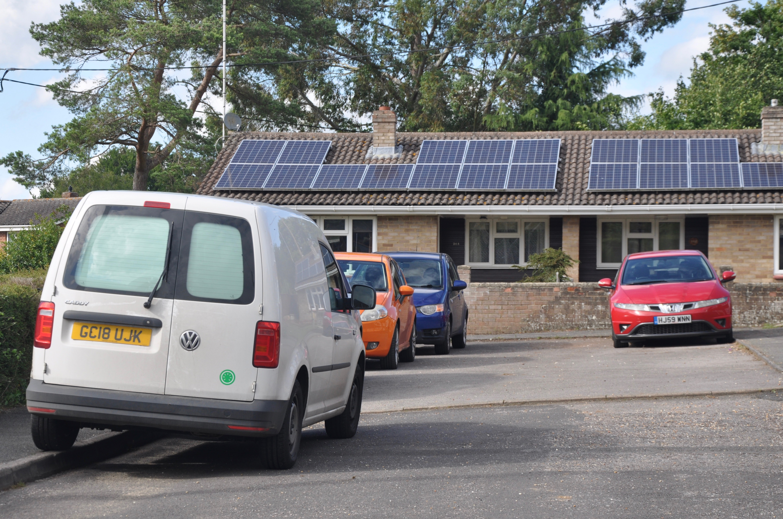
Branksome Close.
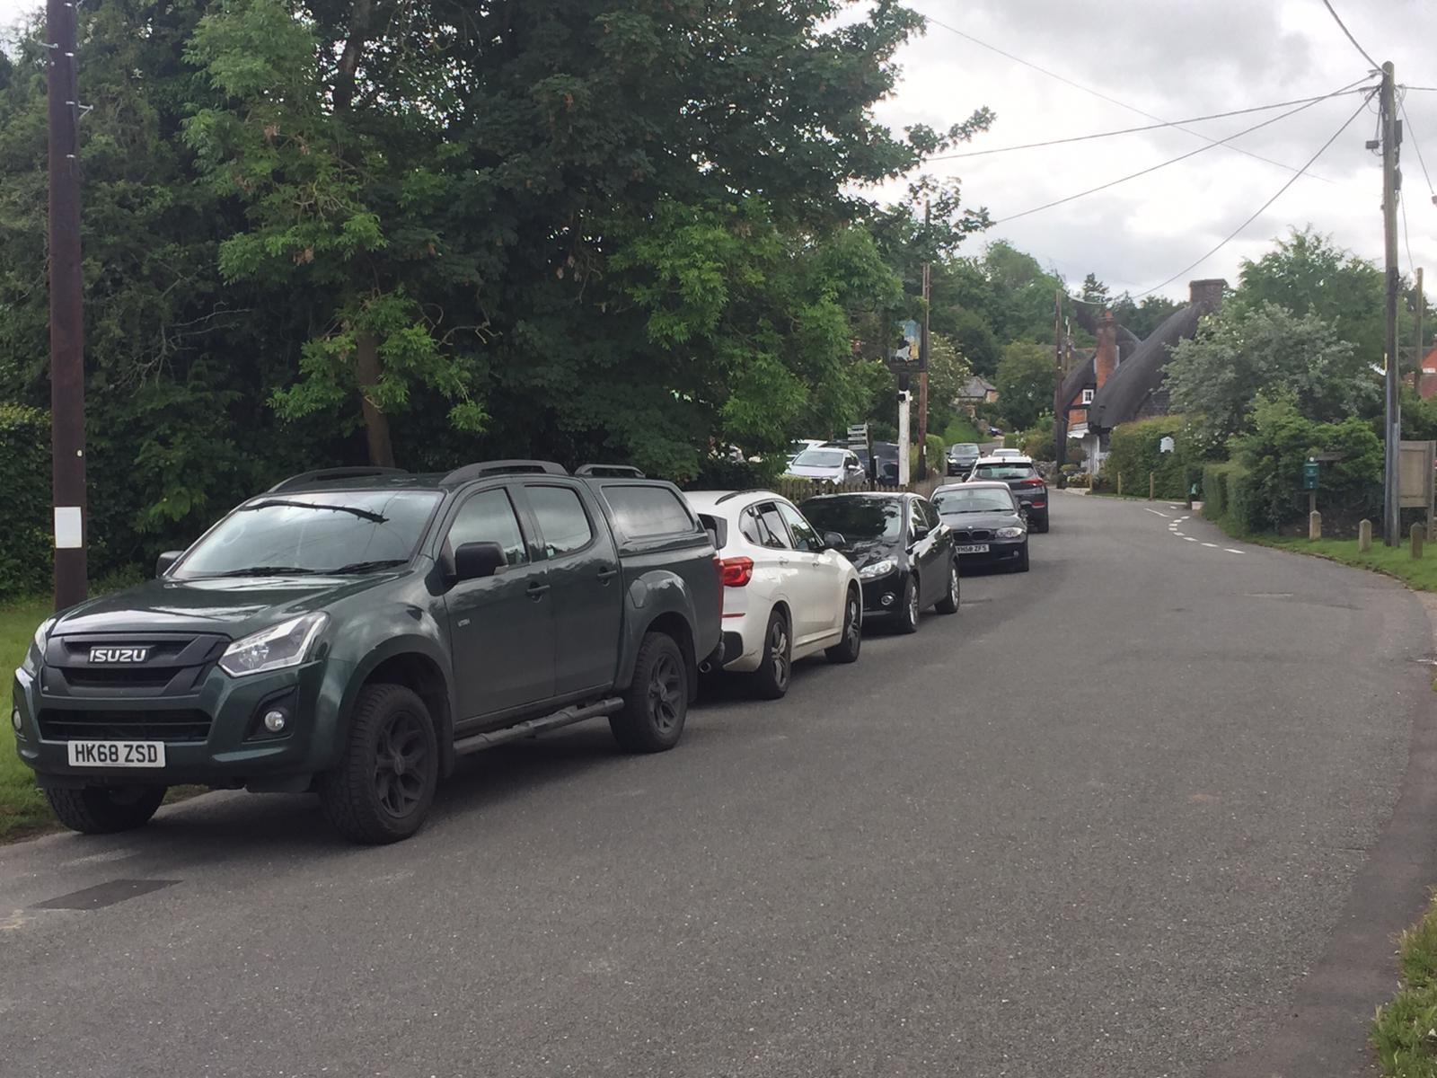
Village Street

Extract from Submission Plan.

Page 34 of Submission Plan.

Parking within the Curtilage
• The narrow lanes within much of Chilbolton Village cannot accommodate additional on-road parking without risking a safety hazard to other road users, or hindrance to the passage, or free flow, of traffic. The limited amount of on-road parking within the Village contributes to its rural character, but on-road parking creates difficulties, in some areas and, for residents in those areas, the issue of parking is a very significant concern.
Example: especially in Summer when the Chilbolton Common attracts many visitors
• Poor levels of public transport and the lack of facilities within the Parish mean that there is a high reliance on the car. Development proposals should address the need for a reduction in the reliance of the use of private vehicles wherever possible, but, in circumstances where this is not possible, appropriate on-site parking provision must be provided in the interests of safety and to protect the rural character of the plan Area.

Policy HD7 : Parking within the Curtilage
Policy HD7: Parking within the Curtilage
a) All new residential development including alterations and extensions which provide extra bedroom(s), must provide resident and visitor car parking spaces so as not to impact on parking provision. Development proposals that result in the loss of existing residential off-street car parking to levels less than those set out below, will be strongly resisted unless
an equal amount of replacement off-street car parking is provided in a suitable location. In line with the NPPF, electric vehicle charging facilities should be encouraged
b) Provision of parking must:
• avoid additional on-road parking for residents and visitors, arising directly or indirectly from the development, which will lead to safety hazards or hinder the passage/free flow of traffic (including use by agricultural vehicles, horses or pedestrians);
• not detract from the rural character of the area;
• consider that the rural location, and the lack of public transport, will require facilities for visitor parking and reflect the fact that more than the normal level of car ownership is likely, and,
• incorporate appropriate sustainable drainage systems.

The following parking standards should be used:
Dwelling size Total spaces
1-bed 2 spaces per unit
2 and 3-bed 3 spaces per unit
4+bed 4 spaces per unit

Policy HD7 Supports Objectives HO01, HO02, HO03, CIO06

